
LYNX
Implementation Choices

Get Started with LYNX

Prepared for: [COMPANY]

Make Work Flow with Hybrid CCPM
Version 7, June 2024

LYNX Implementation choices
Before rolling out Lynx there are several choices that can and need to be made on how you want to use Lynx. The general recommendation is to keep the configuration as simple as possible. And only make the configuration more advanced if there is a hard and specific requirement of the organization which needs to be met.
We have highlighted the paragraphs describing the most common or relevant topics requiring “Implementation Choices” in bold.
Also when LYNX is made available, many settings are set as a “default”, and can be simply left as is (unless there is a specific need).
Every topic is introduced by links to the A-dato knowledge base. After listing the options the pro’s and con’s of the several options are summarized.
The document provides room to document your decision and the way in which you choose to implement your decision in your way of working.

Revision 7, June 2024

Contents
LYNX Implementation choices 2
Contents 3
Space Configuration 5
Calendars and Availability (Capacity) 5
Skill Management and Configuration 9
CCPM Resource Management Options 13
Advanced Skill and Resource Configuration (properties) 14
Register Non-Working periods (Absence) 15
Project and Task behavior 17
Project Structure: Normal Tasks and Workpackages 17
Project Structure: Stage Plans (Level 1) 18
Type of scheduling – Scheduling Directions 19
Rescheduling behavior 21
Migration of Ongoing Projects into LYNX 23
Tasktime reduction & buffer percentage 25
Control Skill and Resource Availability for projects 27
Use of Milestone Buffers with Deadlines 28
Using Constraints 29
Full-Kit Management 30
Dependencies between tasks 31
Summary tasks 32
Long Duration Tasks (like Supplier tasks) 33
Use of Level Of Effort Tasks (with Auto Expand) 35
Autocompletion 36
Lags 37
Colors and Icons 38
Task Management and Resource Assignments 40
Time of resource binding (or Assignment) 40
Task Estimated Time and Task Workload 40
Task Visibility and Distribution Options via My activities 42
Use of task managers 44
Use of resource managers 45
Use of skill managers (Team Manager) 45
Task Execution 47
Update frequency 47
Push or pull information 47
Use of Task Notes 48
Use of Project Notes 49
Working hours administration – Time tracking 49
Other 51
Use of space reader Role 51
Space Feature Selection Table 51

Space Configuration

Calendars and Availability (Capacity)
Skills and Resources can be available full time for projects or have a limited availability (part-time). Resources may also have “other” work or daily tasks outside project work.
The availability (or Capacity) of a Skill or Resource, is determined through setting the “Calendar Availability Rules” within a Calendar.
Any Calendar can be linked to a “Skill” (via the Skill Table) or an individual resource (via the resource table).
https://support.a-dato.com/hc/en-us/articles/360012448934-Calendar-time-and-durations
https://support.a-dato.com/hc/en-us/articles/360016161574-Available-capacity-and-nett-availability

Options:
- Fulltime available (e.g. 5 days at 8 hours per day / 40 hours per week) typically referred to as the Standard Calendar
- Limited availability, set by net availability for a resource in combination with a standard calendar
- Limited calendar availability, set via calendar rules, excluding workdays or by limiting work hours
- Create a “capacity” project to account for other work outside projects
If resources are managed outside LYNX (see next paragraph) is only to be linked to the Virtual Skill concerned.

Pro’s and Con’s

Option | Pro’s | Con’s
Fulltime | Kiss | People will object that not all time is available for projects.  100% utilization will lead you over the ‘edge of chaos’
Limit availability with “net availability” set by resource | You can measure the workload relative to the net availability for projects.  You can choose to go over the net availability for a short period if that helps to shorten the project. | You must remember to enter the correct unit % in the resource requirements.
Limit availability through reducing calendar availability | It will not be possible to allocate more time than available in the calendar. | Project duration will be longer.  Possible confusion between effort and duration.
Add a “capacity” project to account for “other” work | The complete workload of projects and non-project work can be monitored in one resource load overview. | Too much admin, although it is possible to create also projects, using the autocomplete feature for tasks, in combination with LOE Tasks with auto-expand.

Decision:
We choose for option [….] because…
Examples:
- Calendars for different work contracts, 40h (5x 0800-1600) 35h 20h, because contract needs to be adhered.
- Net availability for ‘other work’, determined per individual resource . Because you want to maintain flexibility if higher availability is required for the project progress.

If resources are managed outside of LYNX:
- We do not manage resources in LYNX, and just have 1 standard calendar for a Skill(s). The #FTE available for a skill considers limited availability of the resource pool of the skill.

Implementation Examples:
Fulltime calendar: 40h calendar, Monday – Friday 0800 - 1600
Net availability: 80 % Net Availability in combination with a standard (fulltime calendar) by resource
Parttime calendar: 35h calendar, Monday – Thursday 0800 – 1600, Friday 0800 – 1100
Parttime calendar: 20h calendar, Monday – Tuesday 0800 – 1600, Wednesday 0800 – 1200

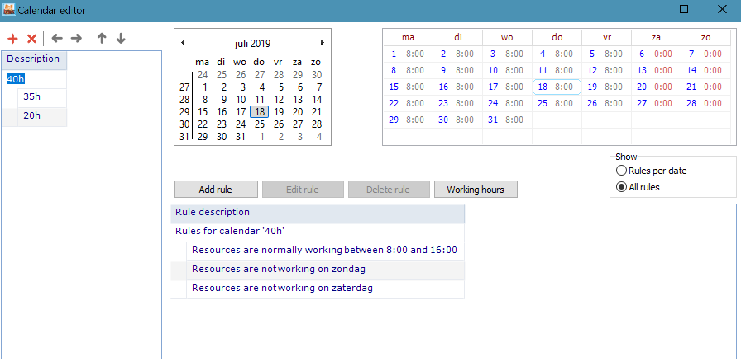
Fulltime calendar: 40h calendar, Monday – Friday 0800 - 1600

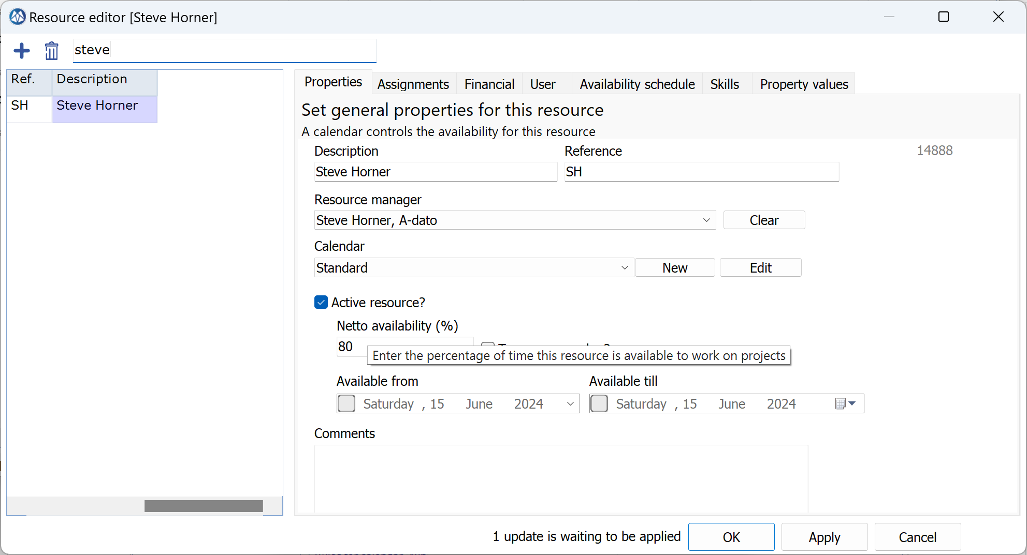
Net availability: 80 % net availability in combination with a standard (fulltime calendar) by resource

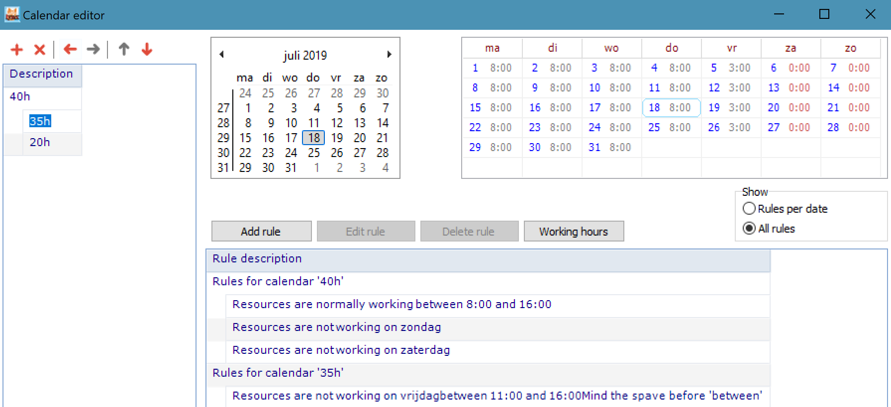
Parttime calendar: 35h calendar, Monday – Thursday 0800 – 1600, Friday 0800 – 1100

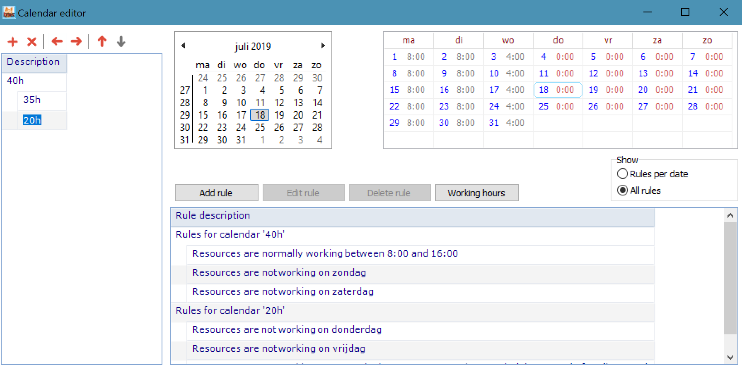
Parttime calendar: 20h calendar, Monday – Tuesday 0800 – 1600, Wednesday 0800 – 1200

Skill Management and Configuration
https://support.a-dato.com/hc/en-us/articles/360012448954-Skill-and-resource-configuration
A driving principle for a CCPM implementation is to move away from planning and scheduling by individuals (by resource name) and to start planning and scheduling at a higher aggregation level or at Skill Level first.
Eventually, resources need to be assigned upon starting the execution of a task as a second step (also referred to as “late binding”). Theses assignments may take place via LYNX, if resources are managed within LYNX or may take place outside LYNX, if resources are managed outside LYNX.
All options mentioned below enable and assume planning and scheduling at Skill Level first.

Options:
- Normal skills
- Virtual skills with names (and confirmations of resource assignments to tasks)
- Virtual skills without names
- (Team skills (See LYNX TameFlow Implementation Choices))
Observations:
In many implementations there is a mix of Normal Skills and Virtual Skills (all tree variations)

Pro’s and Con’s
Option | Pro’s | Con’s
Normal Skills  with *soft and hard assignments of resources. Availability driven by the total of calendar availability of individual resources implementing the skill  Resources are managed within LYNX. | Most intuitive, this is what most people expect, while still planning by Skill, but in combination with late binding.  Availability at Skill level is calculated automatically from the individual availability of resources implementing the skill, also considering non-working periods (like holidays).  Consideration for people that implement multiple skills (cross-skill) or have special “properties”  Automatic LYNX Resource Load balancing of *soft assigned resources  Resource Load Forecast by Resource, includes *soft assigned resources to tasks | Task durations may extended due to non-availability of individuals.  Cross skill allocation can be difficult to grasp/understand.  Introduces “Resource Management” in the implementation.  More risk of keeping “old behavior with early binding / “kopf-monopole”.
Virtual Skills with Resources  Skill Availability is determined by a #FTE set for the Skill and the associated Calendar.  Resources are managed within LYNX. | More focus on planning by “Skill” in combination with late binding. Gets closer to the CCPM philosophy than the normal skills.  Allows Resource Assignment Confirmations to tasks and track resource load by resource. | No consideration for:  - resources with multiple skills (cross-skill)  - limited availability of individual resources  Manual Maintenance of Skill availability in the skill table  No Resource Load Forecast, including *soft assigned resources to tasks
Virtual skills (no Resources)  Skill Availability is determined by a #FTE set for the Skill and the associated Calendar.  Resources are managed outside LYNX. | More focus on planning by “Skill” and late binding.  Avoid that “traditional” resource management distracts | No consideration for:  - resources with multiple skills (cross-skill)  - limited availability of individual resources  No resource management.
Team skills | See LYNX TameFlow

Examples
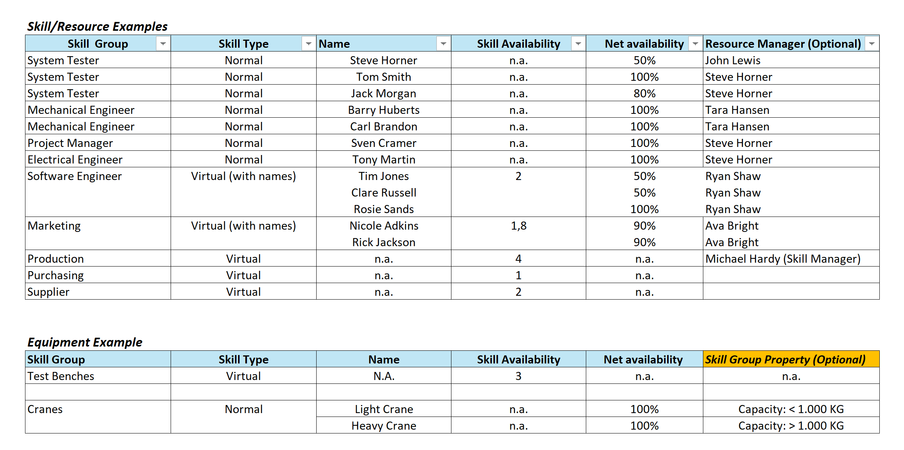

Decision:
We choose for option [….] because…
We think we need to use normal skills. Because this is what the organization expects. We are open to try virtual skills because it removes the distraction of ‘detailed resource allocation’.
In case of virtual skills there might be a resource allocation meeting that determines the actual resources for the upcoming workpackages.
Compare a plan with virtual skills with a plan using normal skills.

Implementation Examples
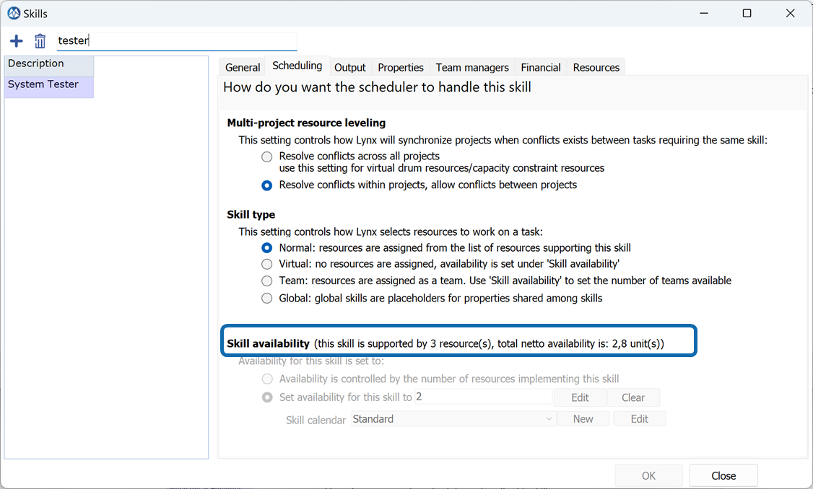
Option 1: Normal Skill Configuration
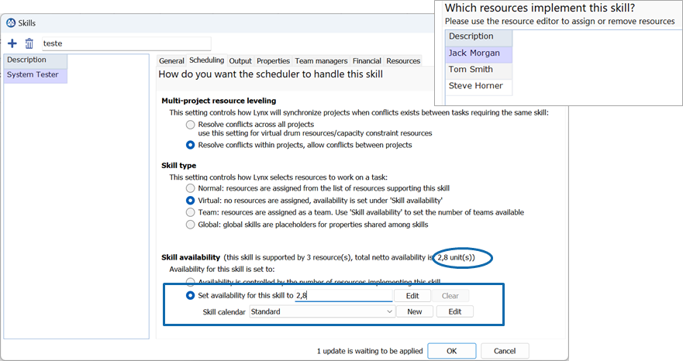
Option 2: Virtual Skill Configuration with Resources (3 Testers, with calculated Net availability of 2,8)
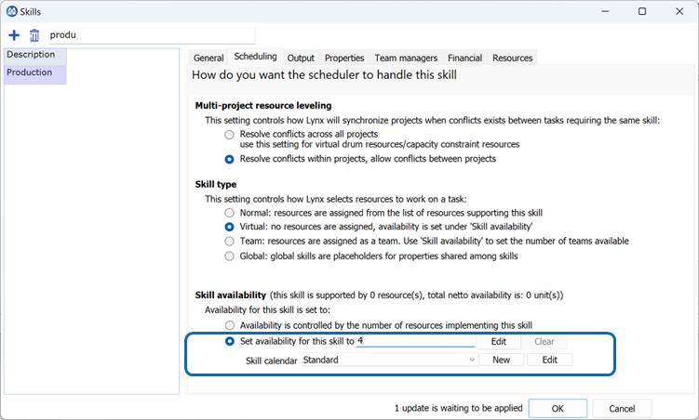
Option 3: Virtual Skill Configuration

CCPM Resource Management Options

Options:
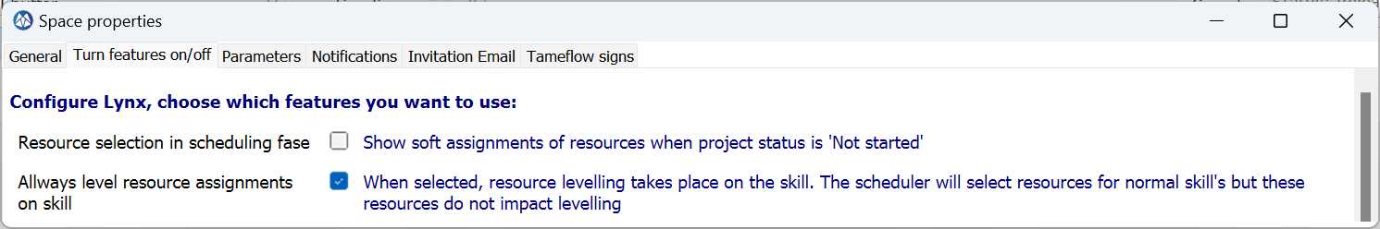
Both options are intended to allow working with resources, but maintain a skill focus as much as possible.
When using Normal Skills, LYNX does a dynamic *soft-distribution across available resources. The *soft-assignment are hidden as they often distract, and the planning is still on Skill level.
The “level resource assignments” on skill level, ensures that the Critical Chain only considers the total Skill availability rather than availability limitations of individual resources.
Both options enable to introduce resource management with LYNX, but also adhere to the CCPM principles and Skill Focus as much as possible.
It also allows to implement a Normal Skill with Properties setting (see next paragraph) to behave like a Virtual Skill from a planning and scheduling perspective, but also work with properties defined at a resource level, like in the example “skill/resource matrix” including profiles below:
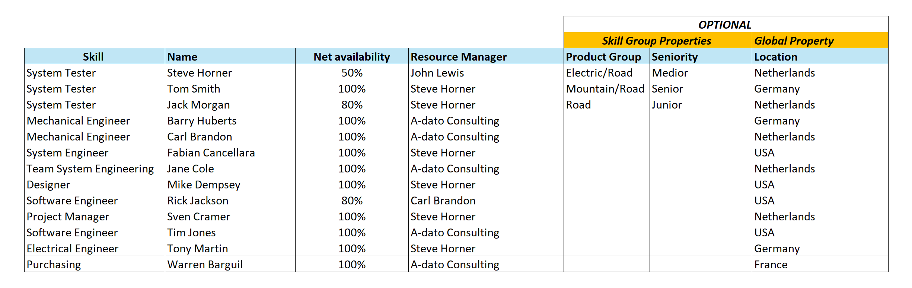

Pro’s and Con’s
Option | Pro’s | Con’s

Observations:
Global Skill settings allow to add organization structures to the resource properties, like department, location

Decision:
We choose for option [….] because…

Implementation:

Advanced Skill and Resource Configuration (properties)

Options:
- Skill Profiles, using Skill Properties
- “Global” Skills with Properties
See example “skill/resource matrix” including profiles below:

Pro’s and Con’s

Option | Pro’s | Con’s
General | Ability to pre-select “matching” resources by property as a default for a project.  Ability to track overall resource load more specifically and by property | More admin and data-maintenance

Observations:
Global Skill settings allows to add organization structures to the resource properties, like department, location

Decision:
We choose for option [….] because…

Implementation:

Register Non-Working periods (Absence)
Non-working periods can be entered in LYNX via the Resource Table. However, it is also possible to import non-working periods automatically from other HR are Time Management systems.

Options:
- Register everything more than 0,5 day
- Register everything more than 1 day
- Register everything more than 5 days
- Do not register
- Do not register, make general reservation through net availability

Pro’s and Con’s
Option | Pro’s | Con’s

Observations:
- This registration is only applicable if resource are entered in the system and in combination with Normal Skills or Virtual Skills with resources
- Most customer choose to only enter absence of > 1 or 2 days

Decision:
We choose for option [….] because…

Implementation:
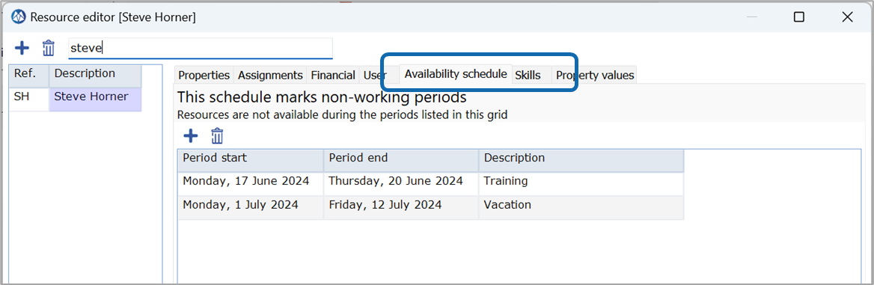

Project and Task behavior

Project Structure: Normal Tasks and Workpackages
LYNX provided the possibility to break-down a main task (Workpackage) in multiple Cards (like Sub-tasks, User Stories, etc..):
Plan with Level 2 Tasks
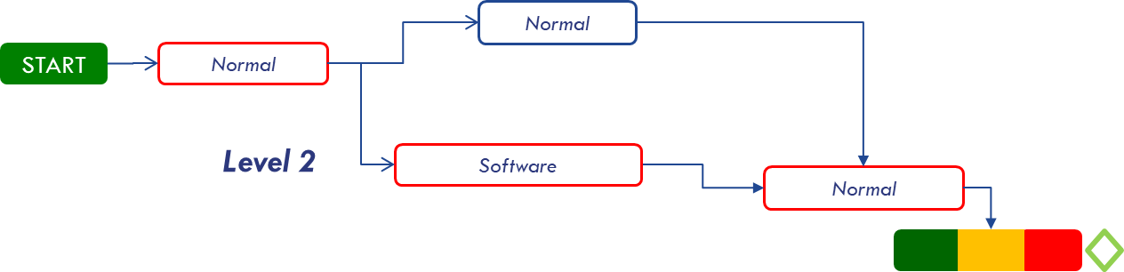
Plan with a level 2 Workpackage Task and Level 3 Cards
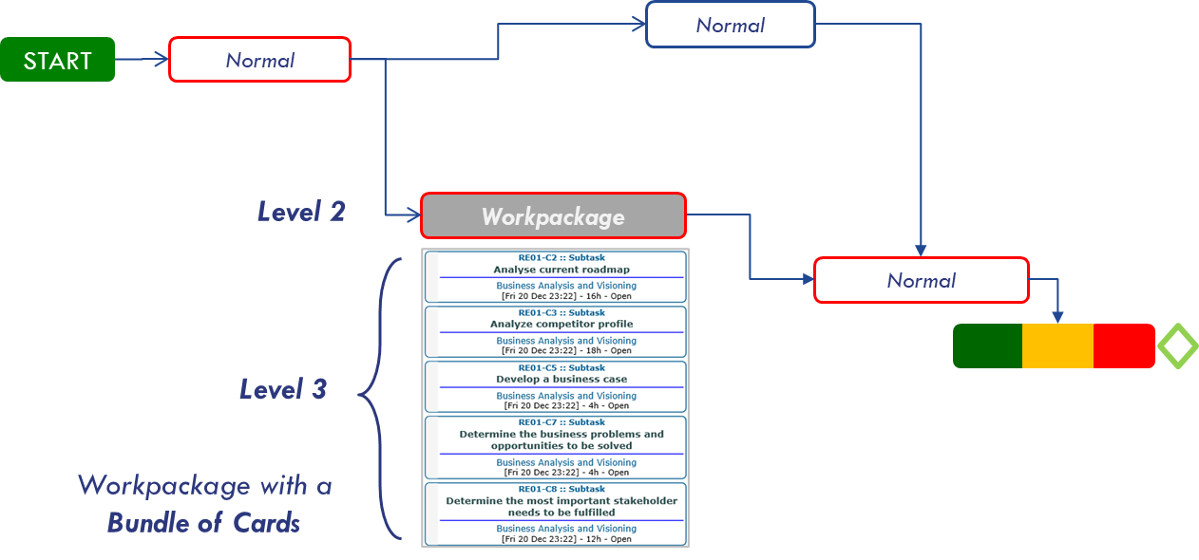

Options:
- Only use task type “Normal”
- Multi-level structure with Level 2 Workpackages and Level 3 Cards (e.g. Subtasks, Userstories, etc.)

Pro’s and Con’s

Option | Pro’s | Con’s
Type Normal Only |  | Risk of many small task (cards) confusing the timeline (Gannt) of the project.  Too much detail not relevant for steering and control
Multi-Level, including tasks of Type “Workpackage” | Fewer normal tasks, simpler project plans  Integrates Agile or Kanban workflows in the master timing  High adoption with self-steering teams

Decision:
We choose for option [….] because…

Implementation:
See LYNX TameFlow implementation choices document.

Project Structure: Stage Plans (Level 1)
https://support.a-dato.com/hc/en-us/articles/9029265302045-Introduction-Scenario-Planning-Levels-Detail-Stage-Integrated
https://support.a-dato.com/hc/en-us/categories/360003033277-Financial-Management

Stage Plans can be added for the following purposes:
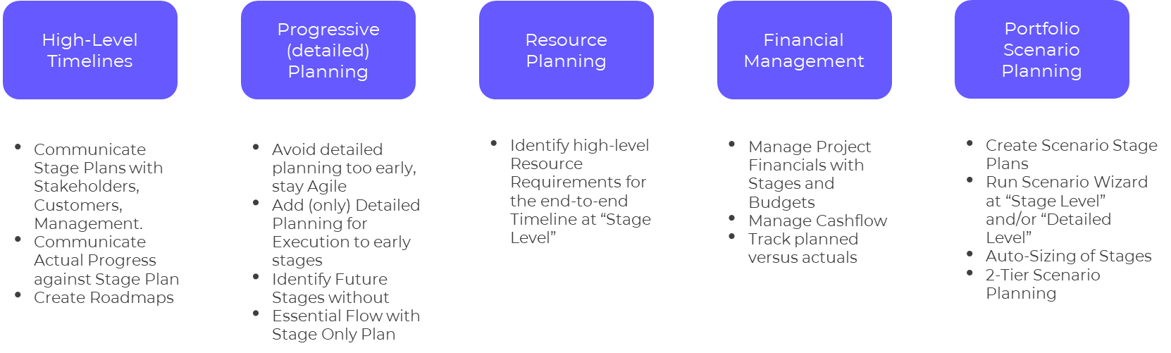

Plan with a level 1 Stages and Level 2 Tasks

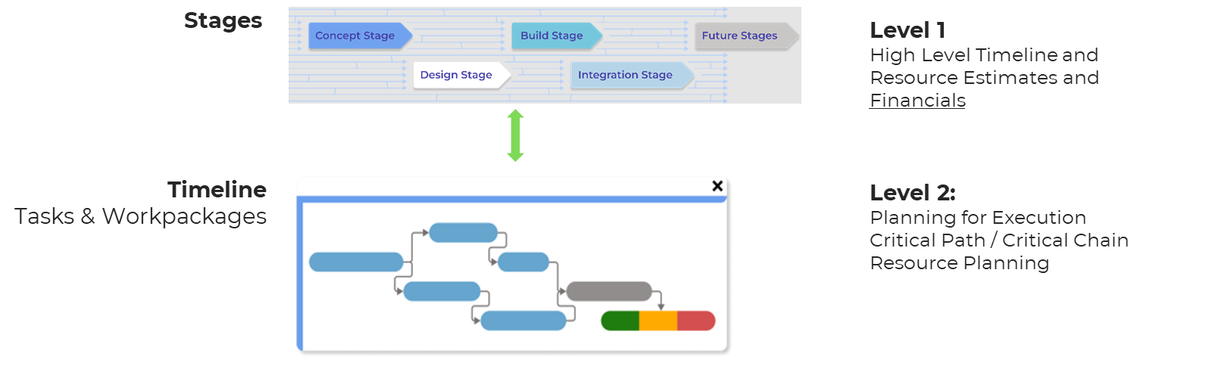

Options:
- Do not use Stages
- Implement Stage Plans with as objective:
  - Communicate High-level Timelines
  - Financial Management
  - Portfolio Scenario Planning

Pro’s and Con’s

Option | Pro’s | Con’s

Decision:
We choose for option [….] because…

Implementation:

Type of scheduling – Scheduling Directions
Lynx offers the option to choose between scheduling “As Soon as Possible” (from left to right – forward scheduling) and “Just in Time” (from right to left – backward scheduling). When using CCPM scheduling this choice can also be made separately for the non-critical feeding chain(s) within a project schedule.
https://support.a-dato.com/hc/en-us/articles/360012449054-Get-started-with-LYNX-for-CCPM-in-30-minutes

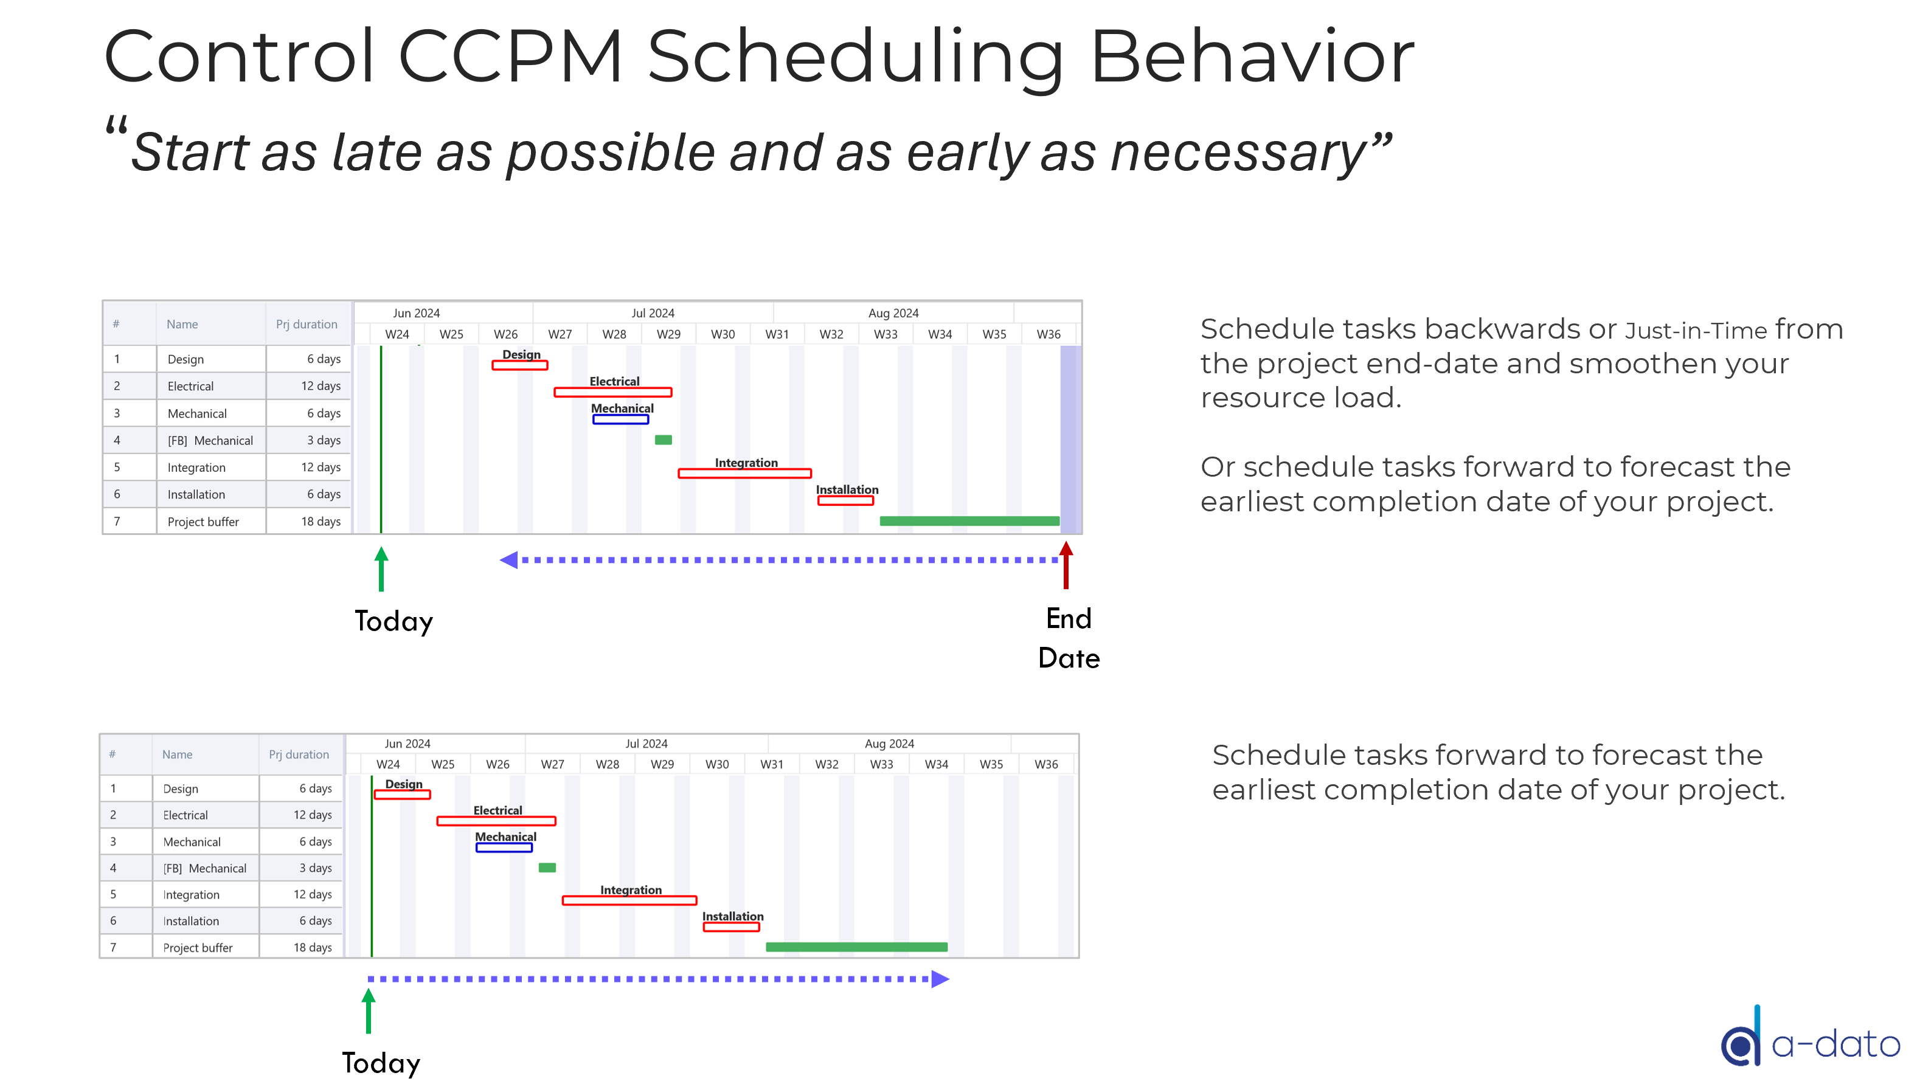
The behavior in the picture above is controlled via the Project Scheduling settings:
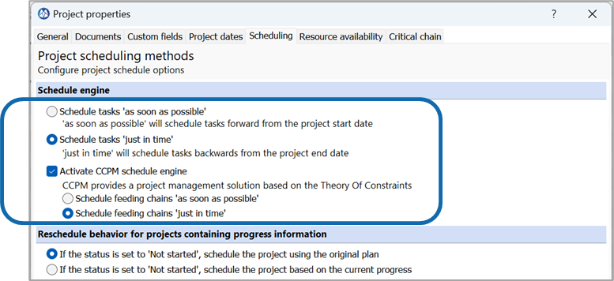

Options
- ASAP for the critical chain, JIT for feeding chains
- ASAP for the critical chain, ASAP for feeding chains
- JIT for the critical chain, JIT for feeding chains

Pro’s and Con’s

Option | Pro’s | Con’s
- ASAP, JIT | The plan will show (from left to right) when the project can be completed, given a start date.  JIT feeding chains will ensure that non critical work is not started earlier than needed. And they allow the feeding buffers to push work to the left when needed to protect the critical chain. | For most people ASAP is more intuitive. Therefore JIT on the feeding chain can appear confusing to people unfamiliar with CCPM.
- ASAP, ASAP | The plan will show (from left to right) when the project can be completed, given a start date.  For most people ASAP is more intuitive and easier to adopt. | Scheduling ASAP continuous old behavior to start all work as soon as possible, with the risk of to much work-in-progress.
- JIT, JIT | Most pure version of the CCPM philosophy.  The plan will show when a project must start, given a due date. | JIT for the CC can be counterintuitive for people who are not familiar with CCPM.

Decision:
We choose for option [….] because…
[COMPANY] will make a policy that every project manager uses these settings.
This needs to be part of the planning transformation phase.

Implementation:

Rescheduling behavior
https://support.a-dato.com/hc/en-us/articles/360012212554-Rescheduling-behavior-for-ongoing-projects
“Rescheduling” of a project may become required, if the scope of the project has expanded significantly, which reasonably cannot be absorbed by the original buffers anymore. Rescheduling requires that the project status is changed from “released” to “not-started”.

Options
- Schedule the project using the original plan
- Schedule the project using the current progress

Pro’s and Con’s

Option | Pro’s | Con’s
- Schedule the project using the original plan | Respect the progress which has been made in the past.
- Schedule the project using the current progress | Do not care about the past (water under the bridge).  Reset the critical chain to the activities which are now critical. | No recognition for the work performed in the past.  However, this can be manually updated via “Setting the Feeding Chain Duration” to account for progress achieved in the past.

Decision:
We choose for option [….] because…
For motivational reasons we want to take the past into consideration. Otherwise you would start with 0% progress after a reschedule operation.
We do want to make sure that the project managers cannot reschedule without the consent of the portfolio manager (space owner).

Implementation

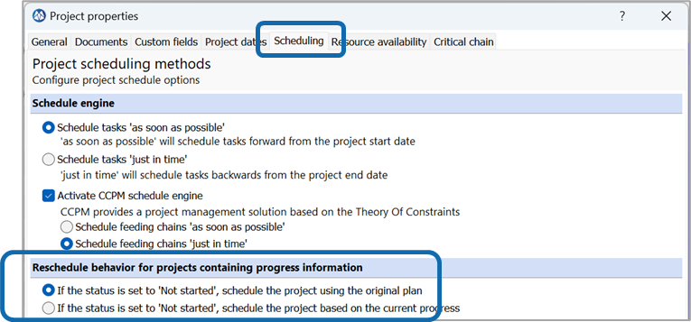
Project can be allowed to set a project to the status “Not-Started” through setting the tick-box in the Feature tab within the “Space Properties”
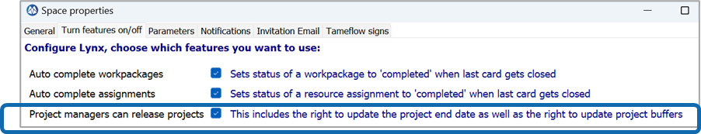
If option 2 is chosen, the Feeding Chain can be manually set via the buffer tab:
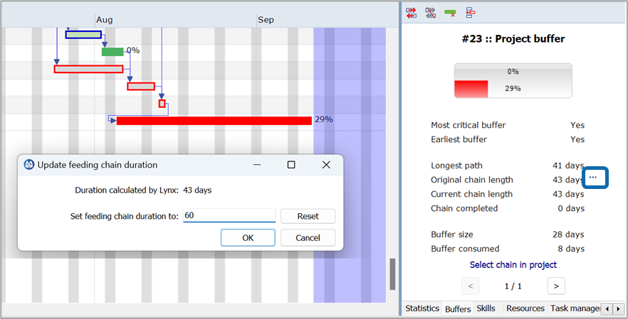

Migration of Ongoing Projects into LYNX

Options
When starting with LYNX ongoing projects have to be entered or imported into LYNX. The following two approaches are available:
- Include tasks that already have been completed Schedule the project using the original plan
- Exclude tasks that already have een completed Schedule the project using the current progress. Update Feeding Chain manually to reflect progress from the past (see above)

Pro’s and Con’s

Option | Pro’s | Con’s
- Include: Schedule the project using the original plan | Respect the progress which has been made in the past.  The full length of the original critical chain is considered automatically, when determining progress | Entering completed tasks takes time.  The project structure may not have been CCPM ready yet before entering in LYNX, as a result progress is not correct.
- Exclude: Schedule the project using the current progress, set feeding chain duration manually | Do not care about the past (water under the bridge).  Reset the critical chain to the activities which are now critical. | No recognition for the work performed in the past.  However, this can be manually updated via “Setting the Feeding Chain Duration”
Observations:
- Identification of progress from the past is a little arbitrarily. Most customers select option 2
- You may also consider to enter a long duration task representing the completed duration in the past, and then choose option 1

Decision:
We choose for option [….] because…

Implementation
If option 2 is chosen, the Feeding Chain can be manually set via the buffer tab:

Tasktime reduction & buffer percentage
https://support.a-dato.com/hc/en-us/articles/360012503333-Add-buffers-and-CCPM-behaviour-to-your-plan
https://support.a-dato.com/hc/en-us/articles/360012564613-When-are-buffers-added-in-a-multi-step-process-
Prior to release of a CCPM project you want to reduce the tasktimes and add buffers to create the desired CCPM behavior. The system offers the option to choose the percentage of tasktime reduction (TTR), which is followed by the option to choose the buffer creation (BC) as a percentage of the chain that feeds to the buffer.
Fundamental choices that need to be made are; do you want to use this mechanism, should it result in the same total project duration, or do you want the resulting project to be shorter in time.
If you want the project to have the same duration before and after TTR and BC the BC % must be chosen such that it compensated for the %TTR.
A longer duration for the project would be chosen if the estimates entered in LYNX are already the most aggressive estimates.
Same duration
- 33 %TTR, 50 %BC
- 20 %TTR, 25 %BC
- 50 %TTR, 100 %BC
Shorter duration
- 50 %TTR, 50 %BC
- 20 %TTR, 10 %BC
- 33 %TTR, 25 %BC
Longer duration
- 0 %TTR, 25 %BC
- 0 %TTR, 50%BC
Types of buffers
- Project buffer only
- Project plus feeding buffers
- Milestone buffers only
- Milestone plus feeding buffers
- Project plus milestone plus feeding buffers

Pro’s and Con’s

Option | Pro’s | Con’s
Same duration | It provides an answer to possible resistance to change.  Once people see that the principle works to complete more projects on time you can consider to switch to shorter duration. | You do not (yet) leverage the full potential of CCPM.
Shorter duration | Benefit from the central limit theorem in CCPM to actually deliver results faster. Enabling the organization to complete more projects. | Oil on the fire for the sceptics.  “Today we have challenges to complete projects on time and you want to make projects shorter?”
Longer duration | Can help to convince the project resources that they get some time to ‘learn the ropes’.  It provides an answer to possible resistance to change.  Once people see that the principle works to complete more projects on time you can consider to switch to same duration or shorter duration. | Projects take longer.

Decision:
We choose for option [….] because…
We choose for the same duration. Maybe we need a longer duration because the current plans are too optimistic.
We choose for 50% reduction and 100% buffer. This gives the earliest warning and most protection.
This also aligns with the assumption that optimistic estimate is 50% of given estimate.
Fixed duration tasks will not be taken into account for determination of buffer size. They can consume buffer. And with 100% buffer there is more room for buffer consumption with lower sensitivity.

Implementation:
The project managers have the option to enter the TTR and buffer creation %. Therefore, this needs to be agreed with the project managers by policy. It cannot be enforced by the application.

Control Skill and Resource Availability for projects
The availability of Skills and Resources maybe a subset from the total resource pool. You may want to define, as a default of the project, which resources qualify as “matching resources” as they have the required qualification for a specific project, like a “Dream Team” for the project.
For example from a team of System Engineers of 10 resources, only 5 would qualify, as there background fit with the technical scope of a project.
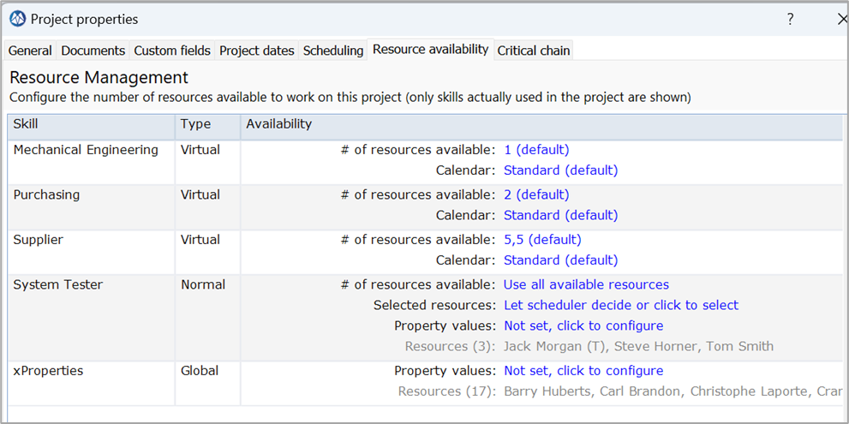

Options:
- Do not limit availability via project properties
- Use Global Skill Property to select resources for example matching the “project location” (pre-select resources in Germany, as the project runs in Germany
- Limit availability by Skill, via # of resources available
- Set matching resources through “Selected resources” (and if configured through “Property values”)

Pro’s and Con’s

Option | Pro’s | Con’s

Decision:
We choose for option [….] because…

Implementation:

Use of Milestone Buffers with Deadlines

Options:
- Only use a Project Buffer (no Milestone buffers)
- Use one or more Milestone buffer and also a project buffer
- Use Milestone buffers only

Pro’s and Con’s

Option | Pro’s | Con’s
Only PB | Fits best with optimizing flow and uncertainty .  The preferred CCPM way | Does not protect other important milestones
MB(‘s) + PB | Project has “contractual” or key-milestone(s) that need to be achieved.  A MB gives focus on these Milestone(‘s) as well. | Risk on traditional planning with many milestones.
MB(‘s) only | Project buffers loose their impact, if already multiple feeding chains with Milestone buffers. | Risk on traditional planning with many milestones.
Observations:
- An IT or Software Development project may only contain a few workpackages, where progress is mainly controlled through the completion of cards. Each workpackage (e.g. release or module) may have it’s own deadline and resulting Milestone Buffer
- If a PM wants a warning only, a “Finish no later than” (FNLT) constraint can be considered (see the paragraph “Constraints”)

Decision:
We choose for option [….] because…

Implementation:
You can control the CCPM settings and insert buffers via the icons on the top-right of the screen:
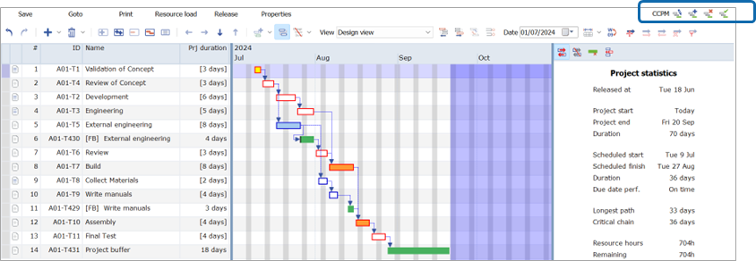

Using Constraints
https://support.a-dato.com/hc/en-us/articles/360012367054-Working-with-constraints
The LYNX Scheduling Engines schedule the tasks according to the chosen scheduling settings and directions (forward or backward scheduling) automatically. Each task will have for example a “scheduled” start and stop date.
Through the use of constraints it is possible however, to “overrule” the scheduling, and position a tasks a date choses by the user manually.
We recommend using “soft” constraints (Finish no later than / Start no earlier than): the LYNX scheduling engine will adhere to these constraints a long as possible, but also overrules if these constraints cannot be kept dynamically.

Options:
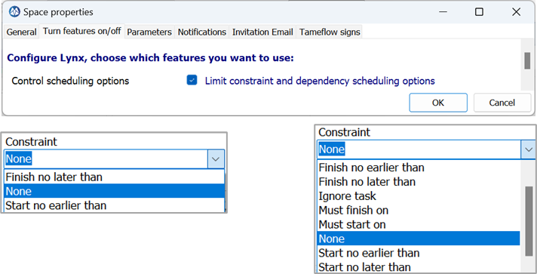

Pro’s and Con’s

Option | Pro’s | Con’s
Using Soft Constraints  - Finish no later than  - Start no earlier than | User can control the position of a task at a specific date and time. | Less optimal scheduling result.
Using Hard Constraints:  - Must start on  - Must finish on | User can control the position of a task at a specific date and time. | Less optimal scheduling result.  If time progresses and Must constraint cannot be met and is also not updated the schedule cannot move anymore, leading to undesired results.

Decision:
We choose for option [….] because…

Full-Kit Management
Define checklists with start checks (Full Kit at task level) and the definition of done (end-checks), via the “notes” icon.

Options:
- Add start checks to tasks
- Add end checks to tasks
- Add Full-Kit Cards (level 3) to a workpackage task

Pro’s and Con’s
Option | Pro’s | Con’s

Decision:
We choose for option [….] because…

Implementation:

Dependencies between tasks
https://support.a-dato.com/hc/en-us/articles/360012449134-Task-dependencies-how-to-add-them-
https://support.a-dato.com/hc/en-us/articles/360012589713-Task-dependencies-Why-use-finish-start-

Options:
The recommendation is to use “Finish-Start” for dependencies between tasks only. This guarantees the best CCPM scheduling results and also makes the schedules more transparent and logical.
The other dependencies can be considered when using one of the other non CCPM scheduling engines available in LYNX.
When working with the CCPM scheduling engine, the following setting is recommended, to blend out the other dependencies.
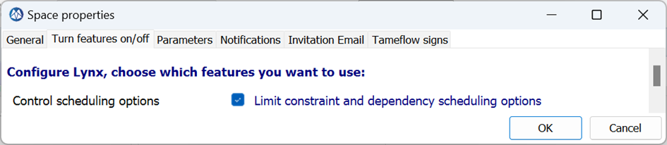

Pro’s and Con’s

Option | Pro’s | Con’s
FS (Default) | CCPM Compliant
FF |  | Do not use when in CCPM mode
SS |  | Do not use when in CCPM mode
SF |  | Do not use when in CCPM mode

Decision:
We choose for option [….] because…
We will only use finish-start dependencies. Closest to the CCPM and best practice in PM.

Implementation:
Control Scheduling options to blend out the non FS dependencies:
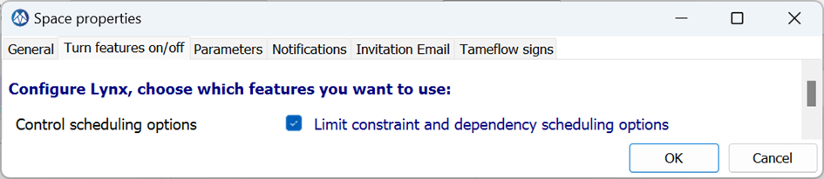

Summary tasks
Often project managers like to extensively use summary tasks to organize their thoughts. Although it helps for the human to group tasks it does not help the computer to schedule the activities in the plan.
Humans like hierarchy in items. The computer needs the sequential logic between tasks (dependencies).
The preferred way of creating hierarchies is by using a work-breakdown-structure. Which can be based on the functions, the product or the deliverables. Depending on the type of project and organization you are working with.
If you want to use summary tasks, we suggest using them to organize and visualize the tasks in phases of the project.
https://support.a-dato.com/hc/en-us/articles/360012438054-Start-group-option

Options:
- Do not use summary tasks
- Use summary tasks to show duration of underlying tasks
- Use summary task for lay-out only
- Use summary task with start group functionality

Pro’s and Con’s

Option | Pro’s | Con’s
Do not use summary tasks | The most simple option.  This helps to focus on the critical chain. | Gantt chart becomes long and possibly hard to interpret for people.
Use summary tasks to show duration of underlying tasks
Use summary task for lay-out only
Use summary task with start group functionality | Simple way of organizing the plan into chunks of work that can be started at the same time. | Cannot be used from the my activities view.  Will start all activities at the same time . Also activities which are not ready to start.

Decision:
We choose for option [….] because…
We need a policy not to link summary tasks. Because this can create be haviour which can be hard to understand once the project is released.

Implementation:
If summary tasks are used, you can toggle between Summary Task view and Flat view:
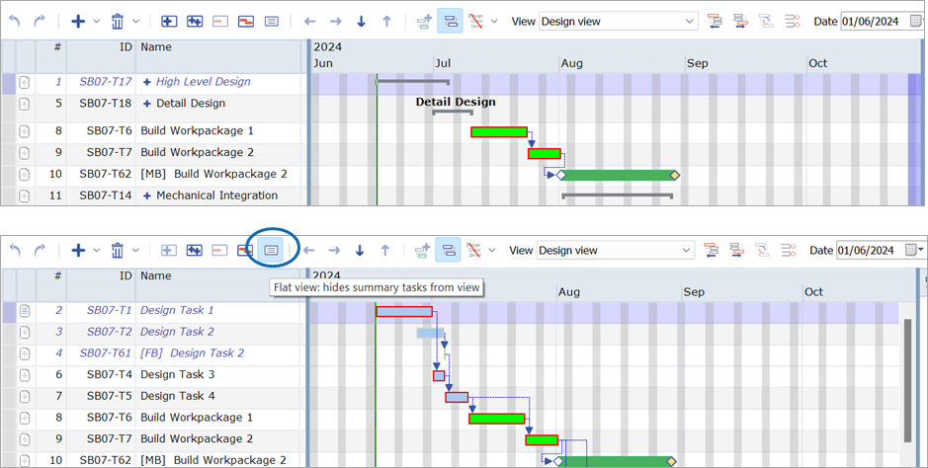

Long Duration Tasks (like Supplier tasks)
Many projects will contain activities which are assigned to 3rd parties. This can vary from the purchasing of parts & supplies to design and manufacturing of assemblies.
These activities need to be modelled in the project and there are different approaches to deal with that.
Note: It may also concern “Long Duration” task, like physical endurance test of e.g. 3 weeks of equipment.
Link to documentation: https://support.a-dato.com/hc/en-us/articles/360012578813-Modeling-of-delivery-lead-times-in-your-plan

Options:
Lags – model a (delivery) monitoring activity around the delivery window with a lag from the ordering activity.
Normal tasks – model the (outsourced) activity as a normal task, followed by a feeding buffer into the critical chain.
Fixed duration tasks – model the (outsourced) activity as a fixed duration task, considering that there is a contractual obligation for the supplier to deliver in the agreed leadtime.
Assign to supplier – the supplier is considered a resource in the system. And you can make purchasing a task manager.
Assign to purchasing – purchasing is directly assigned as skill/resource to the activity.
Autocompletion – In order not to burden purchasing too much with daily updates it can be considered to use the autocompletion feature. Especially because purchasing is likely to have a multiple orders pending at the same time.

Pro’s and Con’s

Option | Pro’s | Con’s
Lags + monitoring task
Normal task | Works for high to medium risk activities. The higher the risk, the more buffer you should use. | TTR will also be applied to the delivery tasks. Without adequate buffer this activity is likely to impact the critical chain.
Fixed duration task | Works for zero risk activities. | The length of the fixed duration task will not be taken into account for the (project) buffer.
Autocompletion | Less admin work

Decision:
We choose for option [….] because…

Implementation:

Use of Level Of Effort Tasks (with Auto Expand)
The Task Type of “Level of Effort” can be used to model especially Project Management or Coordination work, spanning the duration of a phase or multiple tasks.
Task of type Level of Effort are not included in the Critical Chain scheduling. When “Auto-Expand” is set, the task also automatically stretches with the duration of a set of tasks for the project.
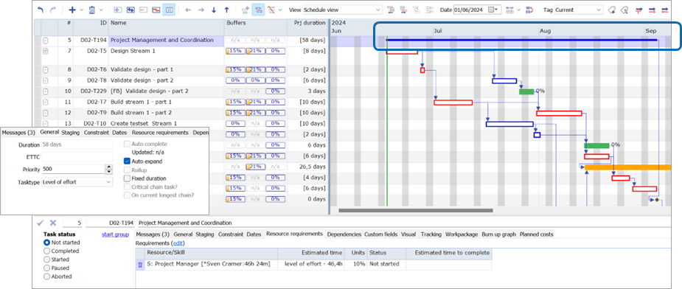

Options:

Pro’s and Con’s

Option | Pro’s | Con’s

Decision:
We choose for option [….] because…

Implementation:

Autocompletion
https://support.a-dato.com/hc/en-us/articles/360012503833-Task-auto-complete-setting

Options:
- Use it
- Do not use it
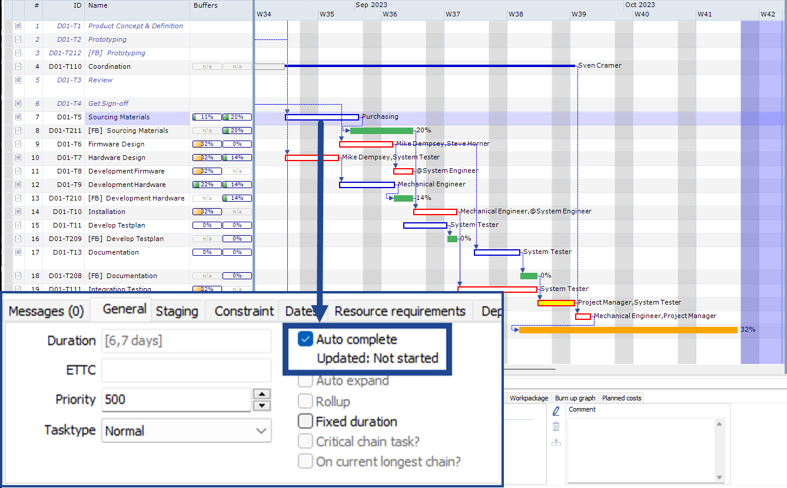

Pro’s and Con’s
Option | Pro’s | Con’s
Use it | No need to perform a daily update to keep the Ettc actual. | No guarantee that the Ettc is realistic. Placing autocomplete on a high risk activity can result in surprises.
Do not use it | Trigger for the task manager to check if the activity is on track. | Perception of a lot of admin work to update the Ettc.

Decision:
We choose for option [….] because…

Implementation:

Lags
https://support.a-dato.com/hc/en-us/search?utf8=%E2%9C%93&category=360001161573&query=lags

Options:
See table below.

Pro’s and Con’s
Option | Pro’s | Con’s
No lag | It is simple and straightforward to understand.
Positive lag | Time of the lag will not count for the Current Longest Chain Completed which is used to measure progress for your project.  This makes it suitable to model waiting time which you do not consider to be relevant for the progress. For example, if you choose to run a control measurement during 2 weeks after you have implemented a process improvement. By modelling 2 weeks of lag the ongoing measurement will not count as progress, the actual work of processing the measurements will count as progress.
Negative lag | The negative lag can be used to start successor task prior to full completion of the preceding task. | The negative lag will not reduce the length of the feeding/critical chain.  Lynx will consider that each activity is an opportunity for variation which can lead to buffer consumption.

Decision:
We choose for option [….] because…
Agree not to use lags. For the same reason as mentioned under constraints.

Implementation:

Colors and Icons
Colors and icons can be set via the Visual Tab:
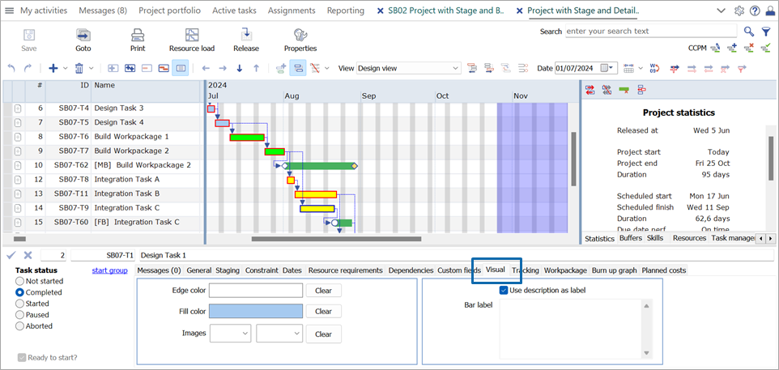

Options:
- Do not use colors or icons for tasks
- Use colors to identify the virtual drum
- Use colors as you like

Pro’s and Con’s

Option | Pro’s | Con’s

Decision:
We choose for option [….] because…

Implementation:

Task Management and Resource Assignments

Time of resource binding (or Assignment)
https://support.a-dato.com/hc/en-us/articles/360012448954-Skill-and-resource-configuration

Options:
- No resource binding – applicable when you have virtual skills implemented without resources
- Late binding by task manager
- Late binding by resource manager
- Late binding by skill manager
- Initial Project level binding of “dream team”. Final late binding by task|resource|skill-manager

Pro’s and Con’s

Option | Pro’s | Con’s

Decision:
We choose for option [….] because…

Implementation:

Task Estimated Time and Task Workload
The Task Estimated Time drives the Duration of a Resource Assignment for the task. The Estimated Workload for a tasks is calculated from the Estimated Time * Units Percentage.
If a task has multiple Resource Assignments, both the Estimated Time as the Unit percentage can vary by Resource Assignment. The calculated workload for a Resource Assignment is displayed in [brackets].
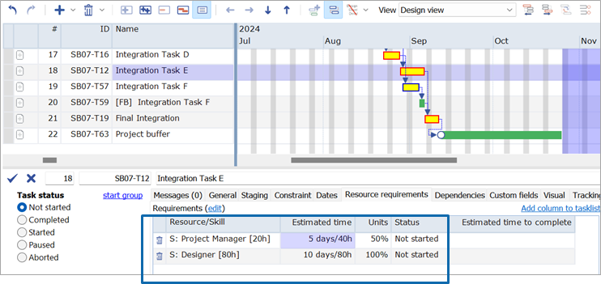

Options:
- Keep default “Units” at 100 %
- Allow reducing “Units” to less than 100 %

Pro’s and Con’s

Option | Pro’s | Con’s
Keep default | CCPM advocates resources to work full-time on a task, to finish as quickly as possible.  Prevents multi-tasking
Change Units | More accurate “workload” appearing in the resource load diagram. | Additional admin  Not a better plan
Observations:
- Most customers stick to the default of 100 %
- Exceptions are for example long duration tasks “monitoring” effort, like a supplier task

Decision:
We choose for option [….] because…

Implementation

Task Visibility and Distribution Options via My activities
https://support.a-dato.com/hc/en-us/articles/360039285453-Distribution-of-Tasks-and-Workpackages-via-My-activities
Access to Tasks via the My activities screen can be controlled by “role” which are linked to “user”. If a “role” is granted access to see tasks via My activities, users with that role, can update the Ettc / Finished by date and do the “binding” (assignment) of a resource or team member to a task.

Options:
Show:
- Tasks for users with the Task Manager Role
- Tasks for users with the binded (assigned) Resource Role
- Tasks for users with the "Selected" Resource Role (“First available operator principle”): show tasks to the candidate resources, set via the project resource assignments pre-selection
- Task for users with the Team Member Role: applicable if a user is Team Member within a “Team Skill”
- Tasks for users with the Skill Manager Role (Team Manager): shows all the tasks assigned to his “Skill”
- Tasks for users with the Resource Manager Role: shows all tasks assigned to the resources assigned to the resource manager
If a Tasks has multiple assignments across multiple skills or resources, only a task manager can update the Ettc/Finished by dialog, via a special “Update all” box across all assignments.:
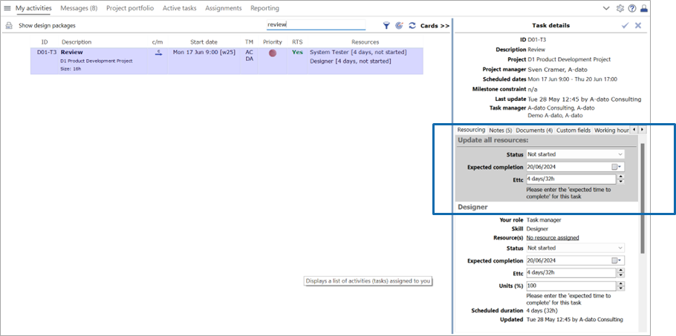

Pro’s and Con’s

Option | Pro’s | Con’s

Decision:
We choose for option [….] because…

Implementation:

Use of task managers
https://support.a-dato.com/hc/en-us/articles/360017555594-Adding-users-and-roles-by-invitation
https://support.a-dato.com/hc/en-us/articles/360012438374-Task-management-guidelines

Options:
- Use a single task manager for a task
- Use multiple task managers / Set a leading Task Manager* for a task
- Do not use task managers
*a leading task manager is visual defined as the Task Manager on top of the task manager list: as example: Task Manager A is responsible for the resource assignment (binding) of a resource. Task Manager B takes over to update the Ettc/Finish by date.
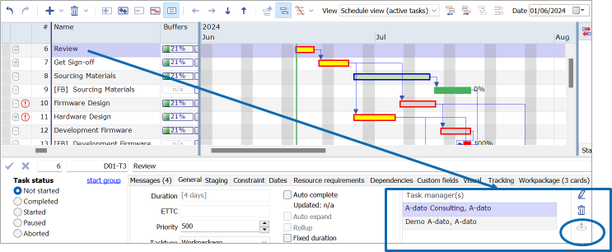

Pro’s and Con’s

Option | Pro’s | Con’s

Decision:
We choose for option [….] because…

Implementation:

Use of resource managers
https://support.a-dato.com/hc/en-us/articles/360017555594-Adding-users-and-roles-by-invitation
https://support.a-dato.com/hc/en-us/articles/360012448954-Skill-and-resource-configuration

Options:

Pro’s and Con’s

Option | Pro’s | Con’s

Decision:
We choose for option [….] because…
Resource managers responsible for hard allocation. Team leaders are resource managers.

Implementation:

Use of skill managers (Team Manager)
https://support.a-dato.com/hc/en-us/articles/360017555594-Adding-users-and-roles-by-invitation
https://support.a-dato.com/hc/en-us/articles/360012589613-Resource-management-for-team-skills

Options:

Pro’s and Con’s

Option | Pro’s | Con’s

Decision:
We choose for option [….] because…
We will not use skill managers. It is not strictly needed.

Implementation:

Task Execution

Update frequency
https://support.a-dato.com/hc/en-us/articles/360012438374-Task-management-guidelines
https://support.a-dato.com/hc/en-us/articles/360012215594-My-activities-or-Active-tasks-

Options:
- Daily
- Every other day
- Weekly

Pro’s and Con’s

Option | Pro’s | Con’s

Decision:
We choose for option [….] because…

Implementation:

Push or pull information

https://support.a-dato.com/hc/en-us/articles/360015349953-Introduction-reporting-and-workflow-automation
https://support.a-dato.com/hc/en-us/articles/360012449234-Work-with-notifications

Options:
- Pull: Let users go to Lynx to update task information
- Push: Remind users by e-mail if task information needs to be updated

Pro’s and Con’s

Option | Pro’s | Con’s

Decision:
As a … we choose for option … because …
Push weekly mails to managers on exceptions.
All other thinks on pull basis.

Implementation:

Use of Task Notes
https://support.a-dato.com/hc/en-us/sections/360002648953-Notes-Documents-and-Notifications

Options:
- General comment
- Buffer recovery note
- Start check
- End check
- Priority change

Pro’s and Con’s
Option | Pro’s | Con’s

Decision:
We choose for option [….] because…

Implementation:

Use of Project Notes
https://support.a-dato.com/hc/en-us/sections/360002648953-Notes-Documents-and-Notifications

Options:

Pro’s and Con’s

Option | Pro’s | Con’s

Decision:
We choose for option [….] because…

Implementation

Working hours administration – Time tracking

Options:

Pro’s and Con’s

Option | Pro’s | Con’s

Decision:
We choose for option [….] because…
Do not use this.

Implementation:
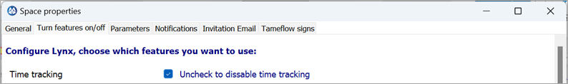

Other

Use of space reader Role
https://support.a-dato.com/hc/en-us/articles/360017555594-Adding-users-and-roles-by-invitation

Options:

Pro’s and Con’s
Option | Pro’s | Con’s

Decision:
We choose for option [….] because…
We choose not to use space readers. We will apply a need to know policy. The different manager roles will provide the people with what they need to know.

Implementation:

Space Feature Selection Table
The Space Feature Selection tables contain several additional settings to control “behavior”. They are set to a default. However, the defaults setting can be changed if needed or required.

Options:

Pro’s and Con’s
Option | Pro’s | Con’s

Decision:
We choose for option [….] because…

Implementation:

Get
Started
Today

Contact:
Address: A-dato B.V.
Professor Snijdersstraat 2,
2628 RA, Delft, The Netherlands

Telephone: +31 75 6409222
E-Mail: sales@a-dato.com
Web: www.a-dato.com


