LYNX Implementation choices
Before rolling out Lynx there are several choices that can and need to be made on how you want to use Lynx. The general recommendation is to keep the configuration as simple as possible. And only make the configuration more complex if there is a hard and specific requirement of the organization which needs to be met.
In this document the choices are listed, with the simplest option in bold. If you choose to use another option we recommend to document the need you intend to satisfy by wanting a more complex option.
Every topic is introduced by links to the A-dato knowledge base. After listing the options the pro’s and con’s of the several options are summarized.
The document provides room to document your decision and the way in which you choose to implement your decision in your way of working.

Revision 5, July 2021

Contents
Space Configuration 4
Resource or SKill Availability of Time for projects 4
Type of skills / resources 6
Advanced Skill and Resource Configuration 8
Register absence 9
Project and Task behavior 10
Project Structure: Normal Tasks and Workpackages 10
Type of scheduling 11
Rescheduling behavior 13
Migration of Ongoing Projects into LYNX 14
Tasktime reduction & buffer percentage 15
Use of Milestone Buffers with Deadlines 17
Dependencies 18
Summary tasks 18
Supplier tasks 20
Autocompletion 21
Constraints 22
Lags 23
Colors 24
Task Management and Resource Assignments 26
Time of resource binding 26
Task Estimated Time and Units percentage 26
Task Distribution Options 28
Use of task managers 29
Use of resource managers 29
Use of skill managers (Team Manager) 30
Task Execution 32
Update frequency 32
Push or pull information 32
Use of task notes 33
Use of project notes 34
Working hours administration – Time tracking 34
Other 36
Use of space reader 36
Financial information 36

Space Configuration

Resource or SKill Availability of Time for projects
https://support.a-dato.com/hc/en-us/articles/360012448934-Calendar-time-and-durations
https://support.a-dato.com/hc/en-us/articles/360016161574-Available-capacity-and-nett-availability

Options:
- Fulltime available (e.g. 5 days at 8 hours per day)
- Limited available, arranged through calendar
- Limited available, set by net availability
- Fulltime available, create project for ‘other’ work

Pro’s and Con’s

Option | Pro’s | Con’s
Fulltime | Kiss | People will object that not all time is available for projects.  100% utilization will lead you over the ‘edge of chaos’
Limited through calendar | It will not be possible to allocate more time than available in the calendar. | Project duration will be longer.  Possible confusion between effort and duration.
Limited, through “net availability” | You can measure the workload relative to the net availability for projects.  You can choose to go over the net availability for a short period if that helps to shorten the project. | You must remember to enter the correct unit % in the resource requirements.
Add “project” for other work |  | Too much admin

Decision:
As a … we choose for option … because …
Calendars for different work contracts, 40h (5x 0800-1600) 35h 20h, because contract needs to be adhered.
Net availability for ‘other work’, determined per individual. Because you want to maintain flexibility if higher availability is required for the project progress.

Implementation Examples:
40h calendar, Monday – Friday 0800 - 1600
35h calendar, Monday – Thursday 0800 – 1600, Friday 0800 – 1100
20h calendar, Monday – Tuesday 0800 – 1600, Wednesday 0800 – 1200
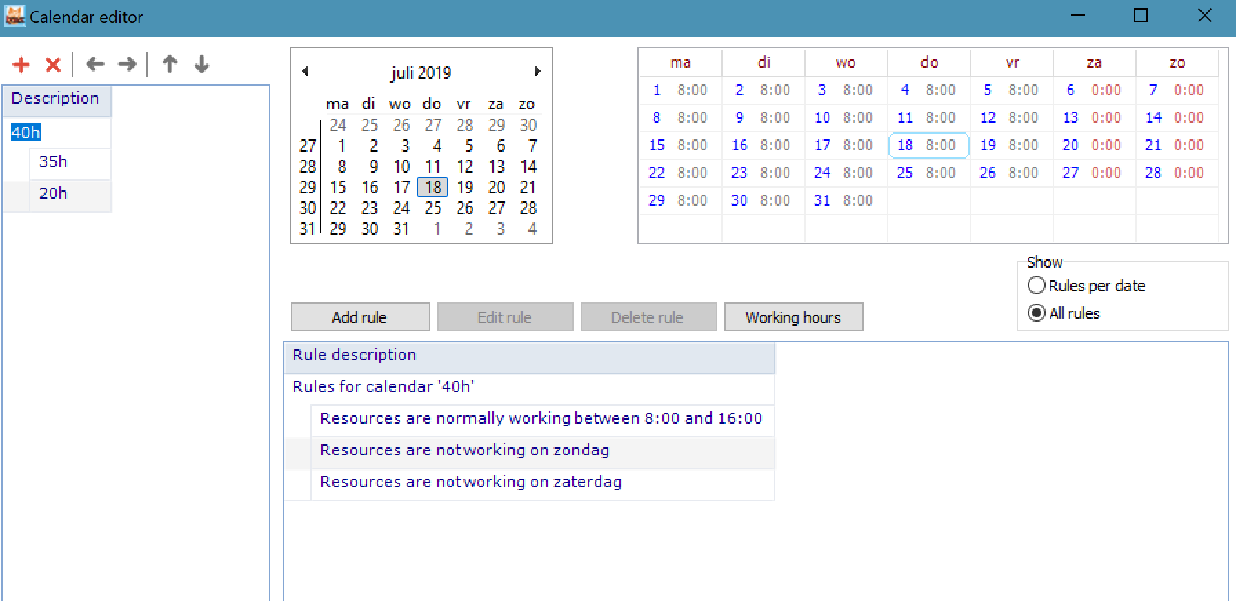
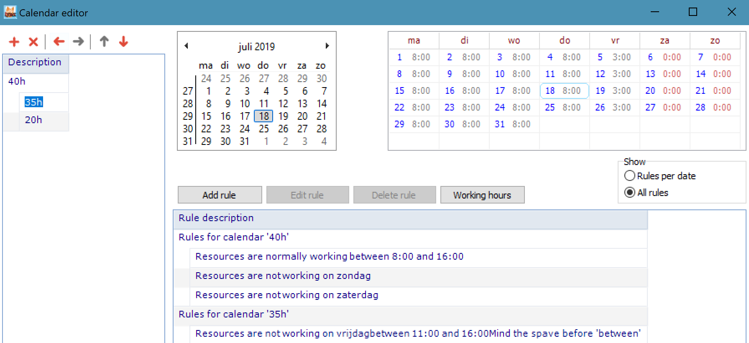
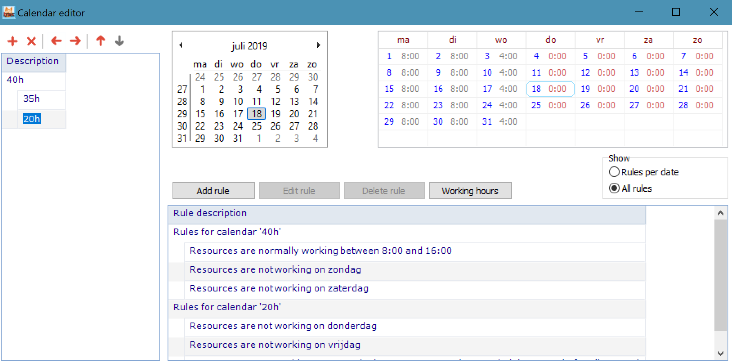

Type of skills / resources
https://support.a-dato.com/hc/en-us/articles/360012448954-Skill-and-resource-configuration
https://support.a-dato.com/hc/en-us/articles/360012589613-Resource-management-for-team-skills

Options:
- Normal skills
- Virtual skills
- Virtual skills with resources (and resource confirmations to tasks)
- Team skills (See LYNX TameFlow Implementation Choices)

Pro’s and Con’s

Option | Pro’s | Con’s
Normal skills (with *soft and hard assignments)  (availability driven by selected calendar for a resource) | Most intuitive, this is what most people expect.  Consideration for personal non availability (like holidays).  Consideration for people that implement multiple skills or have special “properties”  Resource Load balancing of *soft resource assignments | Tasks may be extended due to non-availability of individuals.  Cross skill allocation can be difficult to grasp/understand.  Introduces “Resource Management” in the implementation.  Risk on early binding / “kopf-monopole”
Virtual skills  (availability driven by selected calendar for a skill and #FTE) | Most simple option  Gives most focus | No consideration for:  - resources with multiple skills  - limited availability of a resources
Virtual skills with resources assignments  Still 2 options:  - Availability determined by resources available  - Availability entered manually (derived from total net availability) | See Virtual Skills  Provides also underlying data for calculation of skill availability.  Allows Resource Assignment Confirmations to tasks, preferable once a task is started, and track resource load by resource.  Gets closer to the CCPM philosophy than the normal skills. | Duration of task is determined by the ETTC, it is not calculated by the calendar of the allocated resource.
Team skills | See LYNX TameFlow

Observations:
- in many cases there is a mix of Virtual Skills and Normal Skills
- option 3 is also frequently selected as companies see the advantage of aggregation via the virtual skill, but also have the benefit of actual load information, when assigning a task to a resource

Decision:
As a … we choose for option … because …
Think we need to use normal skills. Because this is what the organization expects. We are open to try virtual skills because it removes the distraction of ‘detailed resource allocation’.
In case of virtual skills there might be a resource allocation meeting that determines the actual resources for the upcoming workpackages.
Compare a plan with virtual skills with a plan using normal skills.

Implementation:

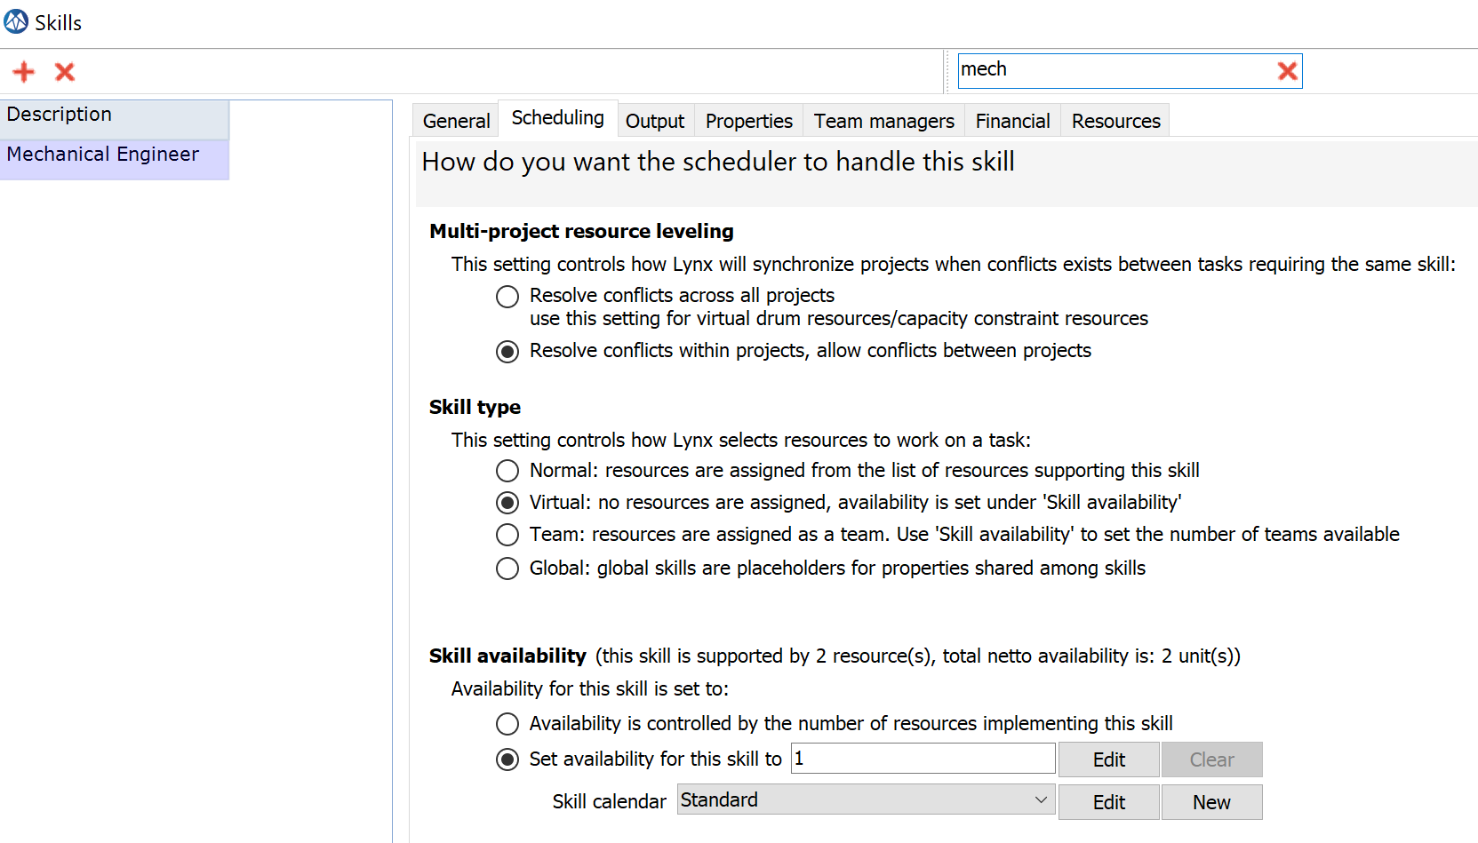

Advanced Skill and Resource Configuration

Options:
- Skill Profiles, using Skill Properties
- “Global” Skills with Properties

Pro’s and Con’s

Option | Pro’s | Con’s
General | Ability to track overall resource load more specifically and by property | More admin and data-maintenance
Observations:
- Global Skill allow to add organization structures to the resource properties, like department, location

Decision:
As a … we choose for option … because …

Implementation:

Register absence

Options:
- Register everything more than 0,5 day
- Register everything more than 1 day
- Register everything more than 5 days
- Do not register
- Do not register, make general reservation through net availability

Pro’s and Con’s

Option | Pro’s | Con’s

Observations:
- This registration is only applicable if resource are entered in the system and in combination with Normal Skills or Virtual Skills with resources
- Most customer choose to only enter absence of > 5 days

Decision:
As a … we choose for option … because …
Do not use this for holidays. Only for special absence like parental leave.

Implementation:

Project and Task behavior

Project Structure: Normal Tasks and Workpackages

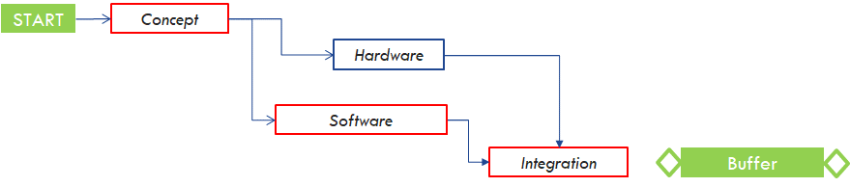
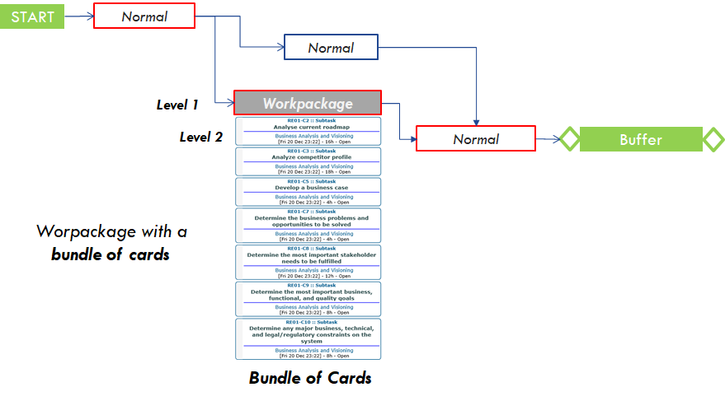

Options:
- Only use task type “Normal”
- Multi-level structure with Level 1 Workpackages and Level 2 Cards (e.g. Subtasks, Userstories, etc.)

Pro’s and Con’s

Option | Pro’s | Con’s
Normal |  | Higher number of tasks  To much detail not relevant for steering and control
Multi-Level | Fewer normal tasks, simpler project plans  Integrates Agile or Kanban workflows in the master timing  High adoption with self-steering teams

Decision:
As a … we choose for option … because …

Implementation:
See LYNX TameFlow implementation choices document.

Type of scheduling
Lynx offers the option to choose between scheduling ‘as soon as possible’ (from left to right) and ‘just in time’ (from right to left). When using CCPM scheduling this choice can also be made separately for the feeding chain.
https://support.a-dato.com/hc/en-us/articles/360012449054-Get-started-with-LYNX-for-CCPM-in-30-minutes
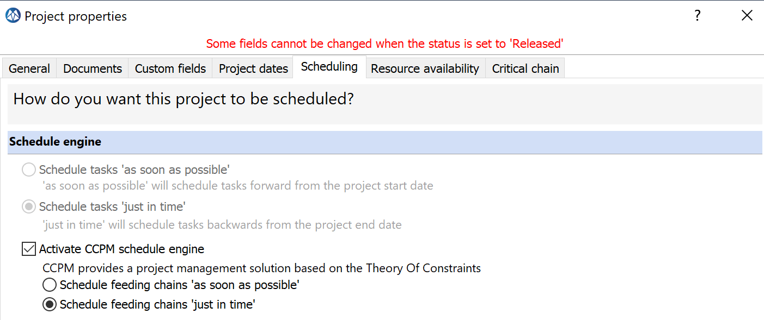

Options
- ASAP for the critical chain, JIT for feeding chains
- ASAP for the critical chain, ASAP for feeding chains
- JIT for the critical chain, ASAP for feeding chains
- JIT for the critical chain, JIT for feeding chains

Pro’s and Con’s

Option | Pro’s | Con’s
- ASAP, JIT | The plan will show (from left to right) when the project can be completed, given a start date.  JIT feeding chains will ensure that non critical work is not started earlier than needed. And they allow the feeding buffers to push work to the left when needed to protect the critical chain. | For most people ASAP is more intuitive. Therefore JIT on the feeding chain can appear confusing to people unfamiliar with CCPM.
- ASAP, ASAP | The plan will show (from left to right) when the project can be completed, given a start date.  For most people ASAP is more intuitive. | Scheduling ASAP removes the possibility for the buffers to start work earlier in order to protect a deadline or critical chain.
- JIT, ASAP | The plan will show (from left to right) when the project can be completed, given a start date. | Scheduling ASAP on the feeding chain removes the possibility for the buffers to start work earlier in order to protect a deadline or critical chain.
- JIT, JIT | Most pure version of the CCPM philosophy.  The plan will show when a project must start, given a due date. | JIT for the CC can be counterintuitive for people who are not familiar with CCPM.

Decision:
As a … we choose for option 4 because this is in line with the CCPM philosophy.

Implementation:
[COMPANY] will make a policy that every projectmanager uses these settings.
This needs to be part of the planning transformation phase.

Rescheduling behavior
https://support.a-dato.com/hc/en-us/articles/360012212554-Rescheduling-behavior-for-ongoing-projects

Options
- Schedule the project using the original plan
- Schedule the project using the current progress

Pro’s and Con’s

Option | Pro’s | Con’s
- Schedule the project using the original plan | Respect the progress which has been made in the past.
- Schedule the project using the current progress | Do not care about the past (water under the bridge).  Reset the critical chain to the activities which are now critical. | No recognition for the work performed in the past.  However, this can be manually updated via “Setting the Feeding Chain Duration”

Decision:
As a … we choose for option … because …
For motivational reasons we want to take the past into consideration. Otherwise you would start with 0% progress after a reschedule operation.
We do want to make sure that the project managers cannot reschedule without the consent of the portfolio manager (space owner).

Implementation:
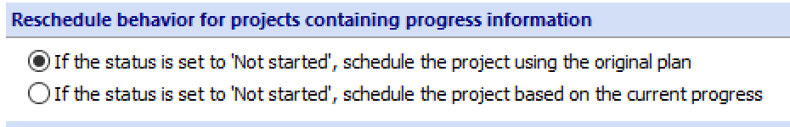

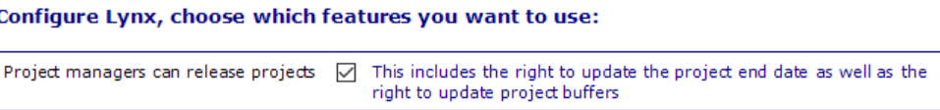

Migration of Ongoing Projects into LYNX

Options
When starting with LYNX ongoing projects have to be entered or imported into LYNX. The following two approaches are available:

- Include tasks that already have been completed Schedule the project using the original plan
- Exclude tasks that already have een completed Schedule the project using the current progress. Update Feeding Chain manually to reflect progress from the past

Pro’s and Con’s

Option | Pro’s | Con’s
- Include: Schedule the project using the original plan | Respect the progress which has been made in the past.  The full length of the original critical chain is considered automatically, when determining progress | Entering completed tasks takes time.  The project structure may not have been CCPM ready yet before entering in LYNX, as a result progress is not correct.
- Exclude: Schedule the project using the current progress, set feeding chain duration manually | Do not care about the past (water under the bridge).  Reset the critical chain to the activities which are now critical. | No recognition for the work performed in the past.  However, this can be manually updated via “Setting the Feeding Chain Duration”
Observations:
- Identification of progress from the past is a little arbitrarily. Most customers select option 2
- You may also consider to enter a long duration task representing the completed duration in the past, and then choose option 1

Decision:
As a … we choose for option … because …

Tasktime reduction & buffer percentage
https://support.a-dato.com/hc/en-us/articles/360012503333-Add-buffers-and-CCPM-behaviour-to-your-plan
https://support.a-dato.com/hc/en-us/articles/360012564613-When-are-buffers-added-in-a-multi-step-process-
Prior to release of a CCPM project you want to reduce the tasktimes and add buffers to create the desired CCPM behavior. The system offers the option to choose the percentage of tasktime reduction (TTR), which is followed by the option to choose the buffer creation (BC) as a percentage of the chain that feeds to the buffer.
Fundamental choices that need to be made are; do you want to use this mechanism, should it result in the same total project duration, or do you want the resulting project to be shorter in time.
If you want the project to have the same duration before and after TTR and BC the BC % must be chosen such that it compensated for the %TTR.
No CCPM
- 0 %TTR,0 %BC
Same duration
- 80 %TTR, 25 %BC
- 66 %TTR, 50 %BC
- 50 %TTR, 100 %BC
Shorter duration
- 80 %TTR, 10 %BC
- 66 %TTR, 25 %BC
- 50 %TTR, 25 %BC
Longer duration
- 0 %TTR, 25 %BC
- 70 %TTR, 50%BC
Types of buffers
- Project buffer only
- Project plus feeding buffers
- Milestone buffers only
- Milestone plus feeding buffers
- Project plus milestone plus feeding buffers

Pro’s and Con’s

Option | Pro’s | Con’s
No ccpm | No change | No benefit
Same duration | It provides an answer to possible resistance to change.  Once people see that the principle works to complete more projects on time you can consider to switch to shorter duration. | You do not (yet) leverage the full potential of CCPM.
Shorter duration | Benefit from the central limit theorem in CCPM to actually deliver results faster. Enabling the organization to complete more projects. | Oil on the fire for the sceptics.  “Today we have challenges to complete projects on time and you want to make projects shorter?”
Longer duration | Can help to convince the project resources that they get some time to ‘learn the ropes’.  It provides an answer to possible resistance to change.  Once people see that the principle works to complete more projects on time you can consider to switch to same duration or shorter duration. | Projects take longer.

Decision:
As a … we choose for option … because …
We choose for the same duration. Maybe we need a longer duration because the current plans are too optimistic.
We choose for 50% reduction and 100% buffer. This gives the earliest warning and most protection.
This also aligns with the assumption that optimistic estimate is 50% of given estimate.
Fixed duration tasks will not be taken into account for determination of buffer size. They can consume buffer. And with 100% buffer there is more room for buffer consumption with lower sensitivity.

Implementation:
The project managers have the option to enter the TTR and buffer creation %. Therefore, this needs to be agreed with the project managers by policy. It cannot be enforced by the application.

Use of Milestone Buffers with Deadlines

Options:
- Only use a Project Buffer (no Milestone buffers)
- Use one or more Milestone buffer and also a project buffer
- Use Milestone buffers only

Pro’s and Con’s

Option | Pro’s | Con’s
Only PB | Fits best with optimizing flow and uncertainty .  The preferred CCPM way | Does not protect other important milestones
MB(‘s) + PB | Project has “contractual” or key-milestone(s) that need to be achieved.  A MB gives focus on these Milestone(‘s) as well. | Risk on traditional planning with many milestones.
MB(‘s) only | Project buffers loose their impact, if already multiple feeding chains with Milestone buffers. | Risk on traditional planning with many milestones.
Observations:
- An IT or Software Development project may only contain a few workpackages, where progress is mainly controlled through the completion of cards. Each workpackage (e.g. release or module) may have it’s own deadline and resulting Milestone Buffer
- If a PM wants a warning only, a “Finish no later than” (FNLT) constraint can be considered (see the paragraph “Constraints”)

Decision:
As a … we choose for option … because …

Implementation:

Dependencies
https://support.a-dato.com/hc/en-us/articles/360012449134-Task-dependencies-how-to-add-them-
https://support.a-dato.com/hc/en-us/articles/360012589713-Task-dependencies-Why-use-finish-start-

Options:

Pro’s and Con’s

Option | Pro’s | Con’s
FF
FS
SS
FF

Decision:
As a … we choose for option … because …

We will only use finish-start dependencies. Closest to the CCPM and best practice in PM.

Implementation:

Summary tasks
Often project managers like to extensively use summary tasks to organize their thoughts. Although it helps for the human to group tasks it does not help the computer to schedule the activities in the plan.
Humans like hierarchy in items. The computer needs the sequential logic between tasks (dependencies).
The preferred way of creating hierarchies is by using a work-breakdown-structure. Which can be based on the functions, the product or the deliverables. Depending on the type of project and organization you are working with.
If you want to use summary tasks, we suggest using them to organize and visualize the tasks in phases of the project.
https://support.a-dato.com/hc/en-us/articles/360012438054-Start-group-option

Options:
- Do not use summary tasks
- Use summary tasks to show duration of underlying tasks
- Use summary task for lay-out only
- Use summary task with start group functionality

Pro’s and Con’s

Option | Pro’s | Con’s
Do not use summary tasks | The most simple option.  This helps to focus on the critical chain. | Gantt chart becomes long and possibly hard to interpret for people.
Use summary tasks to show duration of underlying tasks
Use summary task for lay-out only
Use summary task with start group functionality | Simple way of organizing the plan into chunks of work that can be started at the same time. | Cannot be used from the my activities view.  Will start all activities at the same time . Also activities which are not ready to start.

Decision:
As a … we choose for option … because …
We need a policy not to link summary tasks. Because this can create be haviour which can be hard to understand once the project is released.

Implementation:

Supplier tasks
Many projects will contain activities which are assigned to 3rd parties. This can vary from the purchasing of parts & supplies to design and manufacturing of assemblies. These activities need to be modelled in the project and there are different approaches to deal with that.

Link to documentation: https://support.a-dato.com/hc/en-us/articles/360012578813-Modeling-of-delivery-lead-times-in-your-plan

Options:
Lags – model a delivery monitoring activity around the delivery window with a lag from the ordering activity.
Normal tasks – model the outsourced activity as a normal task, followed by a feeding buffer into the critical chain.
Fixed duration tasks – model the outsourced activity as a fixed duration task, considering that there is a contractual obligation for the supplier to deliver in the agreed leadtime.
Assign to supplier – the supplier is considered a resource in the system. And you can make purchasing a task manager.
Assign to purchasing – purchasing is directly assigned as skill/resource to the activity.
Autocompletion – In order not to burden purchasing too much with daily updates it can be considered to use the autocompletion feature. Especially because purchasing is likely to have a multiple orders pending at the same time.

Pro’s and Con’s

Option | Pro’s | Con’s
Lags + monitoring task
Normal task | Works for high to medium risk activities. The higher the risk, the more buffer you should use. | TTR will also be applied to the delivery tasks. Without adequate buffer this activity is likely to impact the critical chain.
Fixed duration task | Works for zero risk activities. | The length of the fixed duration task will not be taken into account for the (project) buffer.
Autocompletion | Less admin work

Decision:
As a … we choose for option … because …
There are different types of outsourced tasks:
- High risk -> normal task with additional feeding buffer
- Medium risk -> normal task
- Low risk -> fixed duration
We will have to create a policy; not to use lags.

[COMPANY] would like to have snippets of tasks to use as templates.
- Supplier tasks
- Standard start / stop checks
- Workpackages with cards

Implementation:

Autocompletion
https://support.a-dato.com/hc/en-us/articles/360012503833-Task-auto-complete-setting

Options:
- Use it
- Do not use it
- Hybrid solution
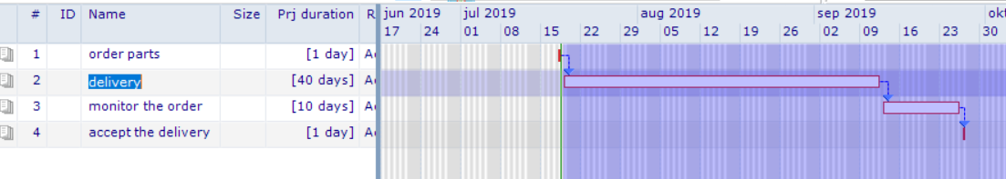
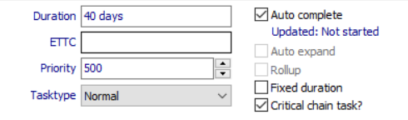

Pro’s and Con’s
Option | Pro’s | Con’s
Use it | No need to perform a daily update to keep the Ettc actual. | No guarantee that the Ettc is realistic. Placing autocomplete on a high risk activity can result in surprises.
Do not use it | Trigger for the task manager to check if the activity is on track. | Perception of non value added work to update the Ettc.
Hybrid solution

Decision:
Only use it for procurement tasks. Not for other tasks.
As a … we choose for option … because …

Constraints
https://support.a-dato.com/hc/en-us/articles/360012367054-Working-with-constraints

Options:
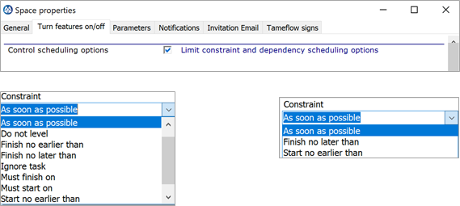

Pro’s and Con’s

Option | Pro’s | Con’s

Decision:
No possibility to use constraints. Get into the philosophy of CCPM. When really needed use milestones.
Restrict options as much as possible.
As a … we choose for option … because …

Implementation:

Lags
https://support.a-dato.com/hc/en-us/search?utf8=%E2%9C%93&category=360001161573&query=lags

Options:

Pro’s and Con’s
Option | Pro’s | Con’s
No lag | It is simple and straightforward to understand.
Positive lag | Time of the lag will not count for the Current Longest Chain Completed which is used to measure progress for your project.  This makes it suitable to model waiting time which you do not consider to be relevant for the progress. For example, if you choose to run a control measurement during 2 weeks after you have implemented a process improvement. By modelling 2 weeks of lag the ongoing measurement will not count as progress, the actual work of processing the measurements will count as progress.
Negative lag | The negative lag can be used to start successor task prior to full completion of the preceding task. | The negative lag will not reduce the length of the feeding/critical chain.  Lynx will consider that each activity is an opportunity for variation which can lead to buffer consumption.

Decision:
As a … we choose for option … because …
Agree not to use lags. For the same reason as mentioned under constraints.

Implementation:

Colors

Options:
- Do not use colors for tasks
- Use colors to identify the virtual drum
- Use colors as you like

Pro’s and Con’s

Option | Pro’s | Con’s

Decision:
As a … we choose for option … because …
Not relevant at this time. In the beginning we choose not to colorize. This can always be applied (by convention) later. Otherwise it can be hard to get back to a standard.

Implementation:

Task Management and Resource Assignments

Time of resource binding
https://support.a-dato.com/hc/en-us/articles/360012448954-Skill-and-resource-configuration

Options:
- No resource binding – only possible when you have virtual skills
- Late binding by resource manager -
- Late binding by skill manager -
- Late binding by task manager -
- Project level binding of dreamteam. Final late binding by resource|skill|task manager

Pro’s and Con’s

Option | Pro’s | Con’s

Decision:
As a … we choose for option … because …
Probably late binding by the resource manager. If needed the PM can propose a dreamteam, final decision by resource manager.

Implementation:

Task Estimated Time and Units percentage

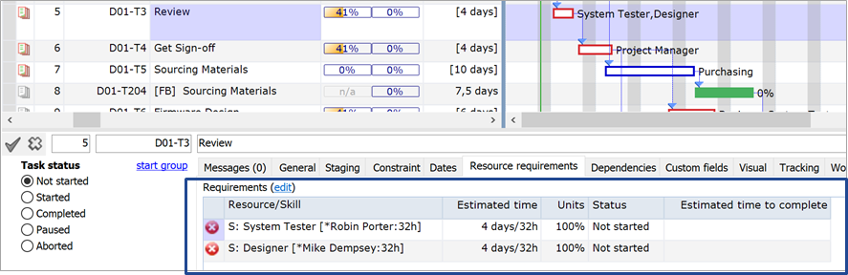

Options:
- Keep default “Units” at 100 %
- Allow reducing “Units” to less than 100 %

Pro’s and Con’s

Option | Pro’s | Con’s
Keep default | CCPM advocates resources to work full-time on a task, to finish as early as possible.  Prevents multi-tasking
Change Units |  | Additional admin  Not a better plan
Observations:
- Most customers stick to the default of 100 %
- Exceptions are for example long duration tasks “monitoring” effort, like a supplier task

Decision:
As a … we choose for option … because …

Implementation:

Task Distribution Options
https://support.a-dato.com/hc/en-us/articles/360039285453-Distribution-of-Tasks-and-Workpackages-via-My-activities

Options:
- Tasks for the Task Manager Role
- Tasks for the Resource Manager Role
- Tasks for the Resource Role
- Tasks for the "Selected" Resource Role
- Tasks for the Team Manager Role

Pro’s and Con’s

Option | Pro’s | Con’s

Decision:
As a … we choose for option … because …

Implementation:

Use of task managers
https://support.a-dato.com/hc/en-us/articles/360017555594-Adding-users-and-roles-by-invitation
https://support.a-dato.com/hc/en-us/articles/360012438374-Task-management-guidelines

Options:
- Do not use task managers
- Use a single task manager for the entire project
- Use multiple task managers

Pro’s and Con’s

Option | Pro’s | Con’s

Decision:
As a … we choose for option … because …
We will use the subproject managers as task manager.

Implementation:

Use of resource managers
https://support.a-dato.com/hc/en-us/articles/360017555594-Adding-users-and-roles-by-invitation
https://support.a-dato.com/hc/en-us/articles/360012448954-Skill-and-resource-configuration

Options:

Pro’s and Con’s

Option | Pro’s | Con’s

Decision:
As a … we choose for option … because …
Resource managers responsible for hard allocation. Team leaders are resource managers.

Implementation:

Use of skill managers (Team Manager)

https://support.a-dato.com/hc/en-us/articles/360017555594-Adding-users-and-roles-by-invitation
https://support.a-dato.com/hc/en-us/articles/360012589613-Resource-management-for-team-skills

Options:

Pro’s and Con’s

Option | Pro’s | Con’s

Decision:
As a … we choose for option … because …
We will not use skill managers. It is not strictly needed.

Implementation:

Task Execution

Update frequency
https://support.a-dato.com/hc/en-us/articles/360012438374-Task-management-guidelines
https://support.a-dato.com/hc/en-us/articles/360012215594-My-activities-or-Active-tasks-

Options:
- Daily
- Every other day
- Weekly

Pro’s and Con’s

Option | Pro’s | Con’s

Decision:
As a … we choose for option … because …
@Patrick to discuss in Zeiss. Hopefully more frequently than weekly.

Implementation:

Push or pull information

https://support.a-dato.com/hc/en-us/articles/360015349953-Introduction-reporting-and-workflow-automation
https://support.a-dato.com/hc/en-us/articles/360012449234-Work-with-notifications

Options:
- Pull: Let users go to Lynx to update task information
- Push: Remind users by e-mail if task information needs to be updated

Pro’s and Con’s

Option | Pro’s | Con’s

Decision:
As a … we choose for option … because …
Push weekly mails to managers on exceptions.
All other thinks on pull basis. Because the JIRA integration will provide realtime updates.

Implementation:

Use of task notes
https://support.a-dato.com/hc/en-us/sections/360002648953-Notes-Documents-and-Notifications

Options:
- General comment
- Buffer recovery note
- Start check
- End check
- Priority change

Pro’s and Con’s
Option | Pro’s | Con’s

Decision:
As a … we choose for option … because …
We want to have template start/stop lists. For other types of notes it is up to the user if and how they want to use it.

Implementation:

Use of project notes
https://support.a-dato.com/hc/en-us/sections/360002648953-Notes-Documents-and-Notifications

Options:

Pro’s and Con’s

Option | Pro’s | Con’s

Decision:
As a … we choose for option … because …
No necessity at this time.

Implementation:

Working hours administration – Time tracking

Options:

Pro’s and Con’s

Option | Pro’s | Con’s

Decision:
As a … we choose for option … because …
Do not use this.

Implementation:

Other

Use of space reader
https://support.a-dato.com/hc/en-us/articles/360017555594-Adding-users-and-roles-by-invitation

Options:

Pro’s and Con’s
Option | Pro’s | Con’s

Decision:
As a … we choose for option … because …
We choose not to use space readers. We will apply a need to know policy. The different manager roles will provide the people with what they need to know.

Implementation:

Financial information

Options:

Pro’s and Con’s

Option | Pro’s | Con’s

Decision:
As a … we choose for option … because …
Do not use this.

Implementation:

